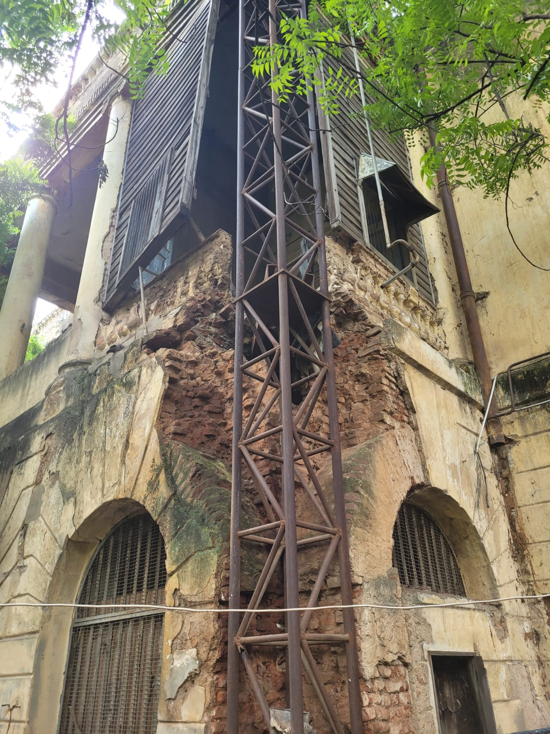

Project Report

From British Residency to

Nizam-British Museum and Cultural Centre-

An Adaptive Reuse Design Project
Hyderabad, India

Schola Chioma Eburuoh

World Heritage USA IEP 2023 Intern

Vasaamaha Consultants, Hyderabad, Telangana, India

WH-USA International Exchange Program 2023
June -August 2023

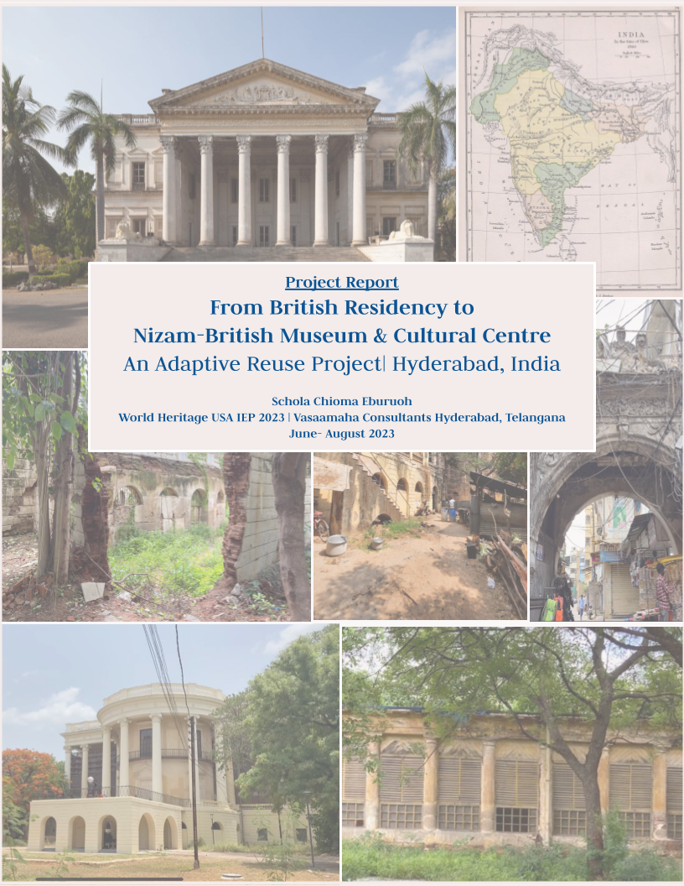

Report

From British Residency to Nizam-British Museum and Cultural Centre

- An Adaptive Reuse Design Project
Hyderabad, India

By

Schola Chioma Eburuoh
World Heritage – USA Intern (IEP 2023)
at Vasaamaha Consultants, Hyderabad, India

Under the guidance of

Vasanta Sobha Turaga
Conservation Architect- Urban Planner
Vasaamaha Consultants, Hyderabad, India

With inputs from

Dr. J. Kedareswari
Museologist, Former Keeper, Salarjung Museum &
Rtd Director, AP Archaeology & Museums Dept., Govt of Andhra Pradesh, Hyderabad

Prof. Naheema Shahnawaz
Architect- Urban Planner
CSIIT School of Planning and Architecture, Secunderabad

Prof. Salma Farooqui
Historian and Director, HK Sherwani Centre for Deccan Studies
Maulana Azad National Urdu University, Hyderabad

Mr. Murali Harathi
Senior Architect and Hyderabad history expert
New Jersey, USA

With permissions from

Telangana State Department of Heritage, Government of Telangana
Greater Hyderabad Municipal Corporation
Mahila Viswavidyalayam

June- August 2023

About

Schola Chioma Eburuoh,
World Heritage USA Intern (2023),
MDeS (Publics), Harvard GSD (2025)
seburuoh@gmail.com

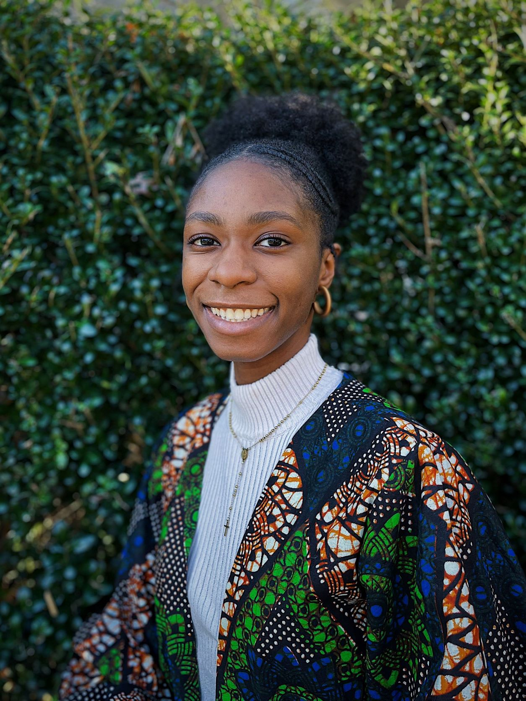Photo

Schola Eburuoh is a Nigerian-American designer and second-year student at Harvard’s Graduate School of Design. She is currently pursuing a Master's in Design Studies degree in Publics domain, projected to graduate in 2025. She has a background in architecture, having completed her Bachelor of Science in Architecture at the Catholic University of America in 2021.

Schola has worked as a design researcher with Gensler as well as a design intern within Gensler Boston’s Strategy Lab. She is extremely passionate about the impact of storytelling in the design field, especially as it relates to built and cultural heritage and environmental sustainability work. During the 2021-2022 academic year, Schola was selected to be a member of the Harvard University Center for the Environment’s Climate Leaders Program (CLP). Schola currently sits as the Outreach Co-Chair for the GSD’s National Organization of Minority Architects and is a coordinator for the Society of St. Vincent de Paul’s “I-Thirst” campaign to build wells in Urualla, Imo State, Nigeria.

Through World Heritage-USA’s Intern Exchange Program, 2023, Schola served as an Architectural Preservation Intern at Vasaamaha Consultants in Hyderabad, India. The following research report details the final project of the 2.5-month internship.

Schola shares much of her research and everyday work on YouTube (@ScholaChioma) and through her website, ScholaChioma.com.

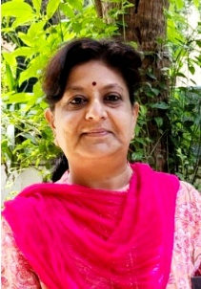
Vasanta Sobha Turaga, Vasaamaha Consultants, Hyderabad, India
+91-9848035124
vasantasobhaturaga@gmail.com

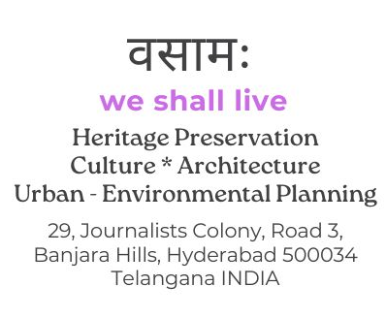

.
Vasaamaha Consultants is a Sole Proprietorship Firm of Ar. Vasanta Sobha Turaga, a Hyderabad-based independent practitioner, Consultant-Conservation Architect and Urban-Regional Planner, working in the fields of Heritage Preservation, Urban Planning and Architecture. Some of her major projects include Research on Golconda (1998-2001), a Project highlighting World Heritage City status potential of Hyderabad (2003) Restoration of Former British Residency for World Monuments Fund (2002-2005), Musi River front revitalisation (2007-2010), Living and Working Conditions of Artisans of Charminar area (2007-2010), Endogenous Tourism Project for UNDP and Govt. of India (2009), Consultant to Satyam Foundation (2006-2009), Heritage Master Plan for Govt. of Karnataka/ADB (2013-14), AP Capital CRDA Master Plan (2016-17), Warangal Master Plan (2017-18), Consultant to Telangana Archaeology and Tourism Dept., Allahabad Smart City (2018), Nellore Master Plan (2020-21), besides carrying out Research for Salarjung Museum, Henry Martyn Institute, Centre for Environment, JNTU and others. She has presented her work at UPenn Smart Doc conference (2010), Icomos GA17 at UNESCO, Paris (2011), Icomos GA at Beijing, China and UN-Habitat Nairobi (GC23, 2011 and GC24, 2013) and at many conferences in India.
Vasanta Sobha is associated with teaching institutions as a visiting Professor. She has submitted her Doctoral research work on “Planning for Conservation of Unprotected Heritage: Study of Samsthans and Zamindari Palaces of Telangana and Andhra Pradesh” (JNAFAU, Hyderabad). She regularly contributes articles to newspapers and technical journals
Since its establishment in 1997, besides regular Consultancy projects, Vasaamaha Consultants has been engaged in different architectural, historical research and documentation works and also in R & D of engineering materials, technology and health assessment of historical structures. Vasaamaha works for policy and governance reforms and action through legal/administrative channels, advocacy programmes, social media campaigns; engages with stakeholders, local communities and educational institutions promoting causes pertaining to preservation of cultural heritage and urban environments; Supports schools, colleges in formation of Heritage Clubs, sensitizing students, faculty to take up various related activities; Organises ‘First STEP’ an online Platform for student projects presentation and students competitions.
A Vasaamaha Heritage Fund was instituted in 2021 to support original studies, research and publication. The on-going projects of the VHF include research on ‘Palmer’s Tomb, Hyderabad, Secunderabad City Research Project, Research on ‘Dargahs of Hyderabad’ and creation of a Database of Artisans and skilled persons in Charminar area of Hyderabad

World Heritage USA

World Heritage USA raises funds, organizes activities, and develops programs on behalf of ICOMOS-USA, the United States National Committee of the International Council on Monuments and Sites. World Heritage USA and ICOMOS-USA promote the sharing of information and ideas on important heritage conservation issues among preservationists around the world.
ICOMOS-USA is part of the worldwide ICOMOS network of people, institutions, government agencies, and private corporations who support the conservation of the world’s heritage. ICOMOS comprises over 11,000 members, organized into 113 national committees. With the support of World Heritage USA, ICOMOS-USA promotes the conservation of the world’s cultural heritage and stronger connections to the global heritage community through advocacy, education, and the international exchange of people and ideas. As the only U.S. professional preservation organization with a global focus, we are the gateway for U.S. preservation professionals and supporters to participate in worldwide heritage conservation activities.
Since 1984, our International Exchange Program (IEP) has embodied the mission of our organization. Each year, we cooperate with heritage partners around the world to provide hands-on training opportunities for emerging professionals in the cultural heritage field in order to expose the next generation of heritage professionals to global best practices of historic preservation and heritage conservation. In this way, the program encourages the cross-cultural exchange of ideas and practices, enabling hosts and interns to learn from one another and increase their impact in the heritage field.
This year, we are thrilled to have partnered with Vasaamaha Consultants who have graciously opened their offices to Schola Chioma Eburuoh, an emerging professional from the United States. Over the summer, Schola worked under the guidance of Vasaamaha Consultants, and was able to use the skills she gained throughout her academic training to research and propose an adaptive-reuse design for Hyderabad’s British Residency.
This incredible project and its final report are a testament not only to Schola’s skills as a cultural heritage practitioner, but also to the benefits of exchanging ideas and perspectives across cultures and areas of expertise. In order to preserve the world’s cultural heritage in the most holistic and effective way possible, we need to encourage continued education, exchange, and partnership at local, national, and international levels. World Heritage USA is proud to have partnered with Vasaamaha Consultants to further this mission and hopes that Schola will continue to promote these same values in her future career.

Preface

It has been a great pleasure to host Ms. Schola Chioma Eburuoh at my Firm Vasaamaha Consultants under the IEP 2023 of the World Heritage USA. I thank WH-USA for this opportunity and Schola for choosing to come to India and work with us.

India is an ancient civilization and a living culture, where heritage from different historical periods coexists and people of different religions and ethnicities live together in harmony, a classic example of unity in diversity, where culture and lifestyle blend and overlap. Hyderabad, presently the fifth largest metropolitan city in India, is truly a living heritage city, with monuments and heritage surviving from the mediaeval period and people practising cultural traditions as a way of life. The 13th CE Golconda Fort and the magnificent Charminar built as a foundation of Hyderabad city in 1591, stand amidst the ever-evolving new, modern Hyderabad. The colonial period of history of Hyderabad has left its footprints in the areas of the British Residency and Secunderabad, the twin city of Hyderabad, the project focus of Ms. Schola Eburuoh under the IEP 2023.

The Hyderabad British Residency, a magnificent State Protected Monument is partly (the Durbar Hall building) restored by the World Monuments Fund, but a large part of the complex is lying in neglect and the whole story of the British presence in the Princely State of Hyderabad (under the Nizam’s) remains untold. Schola was given the task of Adapting the vacant, unrestored buildings of the core Residency to a Museum and cultural centre to tell the story of Nizam-British relations and development of the twin cities of Hyderabad and Secunderabad. Schola was also given the task of connecting the Hashmat Gunj Gate, one of the original gates of the Residency, standing outside the core Residency buildings to the main complex.

Study of any one particular layer of history and heritage in the hustle bustle of a modern city and a mixed living culture is challenging for students as well as professionals. Much more difficult for an international student visiting India for the first time. Schola has diligently worked on all the tasks given to her - from historical research to field visits, from preparation of reports, presentations to interaction with experts, she was all enthusiasm and focus. As part of her project work, Schola not only visited historical sites of the colonial period located in the twin cities, but also visited most of the important museums here to see the content and state-of-the-art display. It is remarkable how Schola comprehended the entire Colonial historical, heritage layers of Hyderabad in a short period of less than 10 weeks, completed an Adaptive Reuse conceptual design and compiled this Report

I would like to place on record that Schola had spent her time here most constructively, with interactions with experts – historians, architects and museologists. The final conceptual design and narrative that she has prepared for converting the Hyderabad British Residency buildings into a Nizam-British Museum and Cultural centre, is to an extent scrutinised and endorsed by leading scholars and professionals fluent with Hyderabad history and heritage and also particularly the British Residency itself. The proposals made by Schola provide a new feasible framework and if detailed further in content and design and implemented, the Nizam-British Museum at the Residency connected to the Hashmat Gunj Gate will become a new urban scale landmark for public use. The proposals are made with the positive hope that all other structures of the Residency will be restored to their past grandeur on par with the Durbar Hall building and the Residency is opened to public as a prominent tourist and educational site, on par with other monuments and Palace museums in Hyderabad.

I thank all the experts who gave time and inputs to Schola. And my juniors Conservation Architects Rajeshwari, Bindu Chandana and Teja Sai Chandra. My heartfelt gratitude to Mr. Murali Harathi, USA for guiding me in hosting an international intern. And finally, my special thanks to Architect Jaswant, for being a constant and supportive friend to Schola during her stay in India. I am guilty of not giving Schola a lot of fun time in India, considering the brevity of her visit, and I thank her for keeping up her joyful and curious spirit during work pressure. I wish Schola good luck for her future.

Vasanta Sobha Turaga
Conservation Architect- Urban Planner August 2023 Vasaamaha Consultants, Hyderabad

Foreword

The British Residency in Hyderabad holds historical significance as it was the official residence of British representatives known as the Residents, stationed at Hyderabad during the colonial period. This is a historic site that played a pivotal role in the history of Hyderabad as it witnessed various events, including the Revolt of 1857, which had a profound impact on the course of Indian history

The history of the British Residency brings up discussions about colonialism, power dynamics, and cultural influences; hence Ms. Schola Chioma Eburuoh’s proposal of having a Museum and a Cultural centre at this site engages with showcasing a slice of Hyderabad’s history for future generations and opening dialogue and discussions about complex historical topics. The vision that Schola has, can provide meaningful insights into the interactions between the British and local rulers, and the socio-political dynamics of the time. This can also become a platform to attract tourists to learn about the region’s history and colonial interactions between different cultures during that era.

The British Residency is a cultural heritage site that reflects the architectural style of its time. The interpretation centre can be a valuable resource for researchers and scholars studying colonial history, architecture, and cultural exchange. It can house documents, photographs, and other materials that facilitate academic research. Researchers, historians, and scholars can benefit from this in terms of gaining access to historical documents, artefacts, and contextual information. This can contribute to a better understanding of the past and the events that shaped the region. An accurate historical timeline prepared to comprehensively project the Nizam-British relations in Hyderabad through the proposed Museum and Cultural Centre at the erstwhile British Residency at Koti, Hyderabad will be an asset in narrating truthful history of Hyderabad to present and next generations.

A new style museum can serve as a gathering point for the local community members who can contribute their knowledge, stories, and artefacts related to the British Residency. Workshops, lectures, and cultural events can be organized to engage the community and raise awareness about the historical significance of the site. This involvement will foster a sense of ownership and pride in the historical heritage of the area. The interpretation centre can, gradually, become a hub for promoting local art, music, crafts, and other cultural aspects and can create a broader understanding of the region’s cultural richness.

With the use of various multimedia tools such as interactive exhibits, audio guides, and visual displays, an engaging and immersive experience can be created for visitors, making the historical information more accessible and enjoyable. Overall, the establishment of Nizam-British Museum at the British Residency in Hyderabad would serve as a vital step in preserving, promoting, and understanding the historical and cultural heritage of the region. It would provide a dynamic space for education, reflection, and engagement with history. Moreover, it is a way to honour the past, learn from it, and create meaningful experiences for people in the present and the future.

I wish Schola all the very best.

Prof. Salma Farooqui
Historian and Director, HK Sherwani Centre for Deccan Studies
Maulana Azad National Urdu University, Hyderabad

Acknowledgements

I am deeply grateful to all those who contributed to the success of this research project and report.

First and foremost, I would like to express my utmost gratitude to my primary supervisor, Ar. Vasanta Sobha Turaga, Founder of Vasaamaha Consultants, for her guidance, support, and encouragement throughout the entire internship. Her mentorship and expertise were invaluable in shaping the direction of my research as well as introducing me to the heritage profession within Hyderabad and Secunderabad.

I also thank World Heritage USA (formerly ICOMOS USA), for the opportunity to partake in the Intern Exchange Program in Hyderabad, Telangana, India for the Summer of 2023. Along with Mr. Narayana of the Department of Heritage Telangana, and Mr. Reddy of the Greater Hyderabad Municipal Corporation. This report would not be possible without the support of these individuals and their associated organizations.

I am also grateful for members of our research team and colleagues such as Ar. Bindu Chandana, G Teja Sai Chandra, and Ar. Jeshwanth Shiva Sai, provided valuable input, insights, and assistance at various stages of the project. Their contributions were critical to the success of this research, and I am deeply grateful for their dedication to heritage and preservation studies.

Finally, I would like to extend my heartfelt thanks to all of the experts and academics in the study who generously shared their time, experiences, and insights. I would particularly like to thank those who partook in video interviews including, Mr. Divay Gupta, Dr. Kedareswari, Prof. Salma Farooqui, Professor Naheema Shahnawaz, Mr. Devender Reddy, and Mr. Murali Harathi. Their willingness to engage in discussion was essential to the success of this project, and we are deeply grateful for their participation.

Overall, this research project would not have been possible without the support and contributions of many people. I am deeply grateful to all of those who helped to make this project a reality and hope that this report and proposal make a meaningful contribution to the field of Preservation in India today.

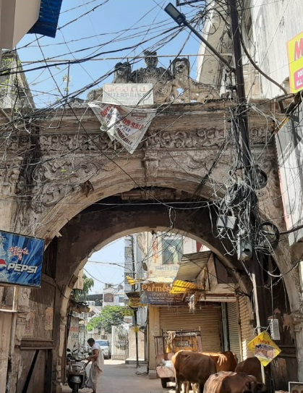

Report

From British Residency to Nizam-British Museum and Cultural Centre-

An Adaptive Reuse Design Project
Hyderabad, India

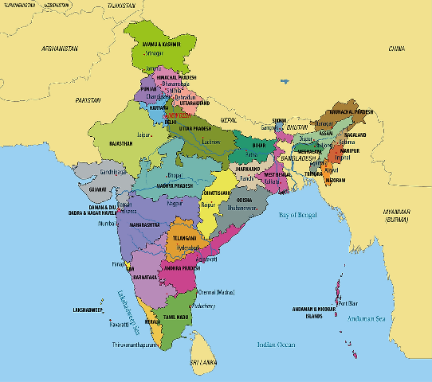
Telangana and Andhra Pradesh States in India (Source: worldatlas.com)
Telangana State was bifurcated from Andhra Pradesh State in 2014

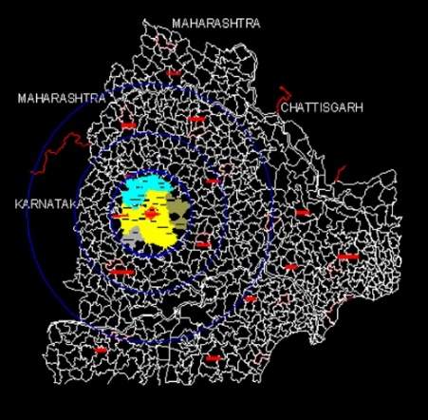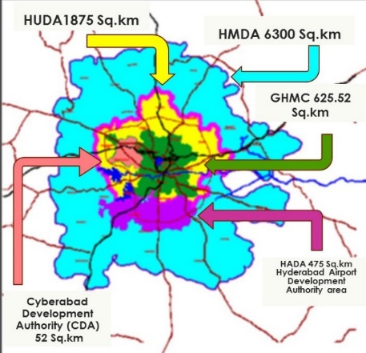
Hyderabad city, Telangana (Source: Vasaamaha)

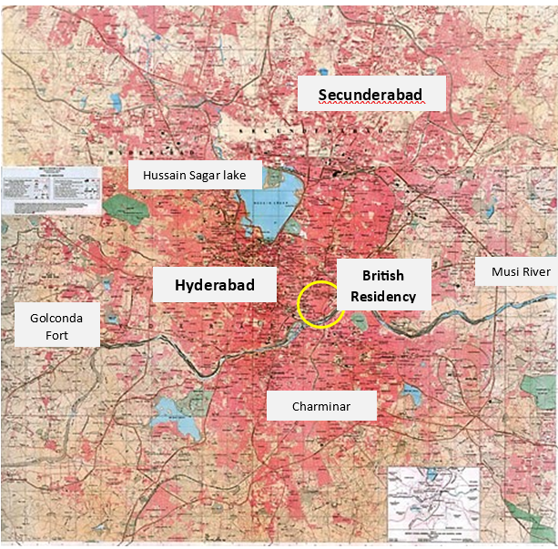
GHMC – Twin cities of Hyderabad and Secunderabad – Location of British Residency (Survey of India Map)

Contents

CHAPTER PAGE #

- About……………………………………………………………………..4
- Message From World Heritage USA…………………………………….6
- Preface……………………………………………………………………7
- Forwards………………………………………………………………….8
- Acknowledgments………………………………………………………..9
- Contents………………………………………………………………….12
- Abstract…………………………………………………………………..13
1. INTRODUCTION……………………………………………………….14
1.1 Project Aim, Objective, and Scope
1.2 The History of Hyderabad

1.3 Defining Hyderabad and Secunderabad
1.4 Preservation of the British Residency Today
2. DESIGN PROPOSAL…………………………………………………..32

2.1 Defining the Museum and Cultural Center
2.2 Methodology
2.3 Writing the Museum Narrative
2.3.1 Site Proposal
2.3.2 Building Proposal

3. DISCUSSION……………………………………………………………58

3.1 Writer’s Personal Reflection
3.2 Spaces for Further Discourse
4. ENDNOTES……………………………………………………………...60
5. REFERENCES…………………………………………………………...62
6. APPENDIX………………………………………………………………63

Abstract

The British Residency of Hyderabad is the pinnacle-built representation of the British-Nizam relations of the 1798-1947 colonial period, yet as of recently, a cohesive and authentic narrative of the residency, along with a number of supporting structures of the time, has not been told. This research aims at portraying an honest and clear understanding of the Nizam-British relations as it relates to the British-designed, Indian-built structures of Hyderabad and Secunderabad specifically. The concluding findings are portrayed through the adaptive reuse proposal of the British Residency to hold this pertinent heritage through an expansion and redesign of the current interpretation centre hosted within the building and maintained by Osmania University (now Mahila University).

1. INTRODUCTION

1.1 Project Aim, Objective, and Scope

The Former British Residency complex (1803-06) is a State-Protected Monument located in the Koti area of Hyderabad, Telangana. Currently residing in the Mahila University campus, the Residency’s main Durbar Hall has recently completed restoration and contains an interpretation centre through support from the World Monuments Fund, the Department of Heritage, the Government of Telangana, and others.

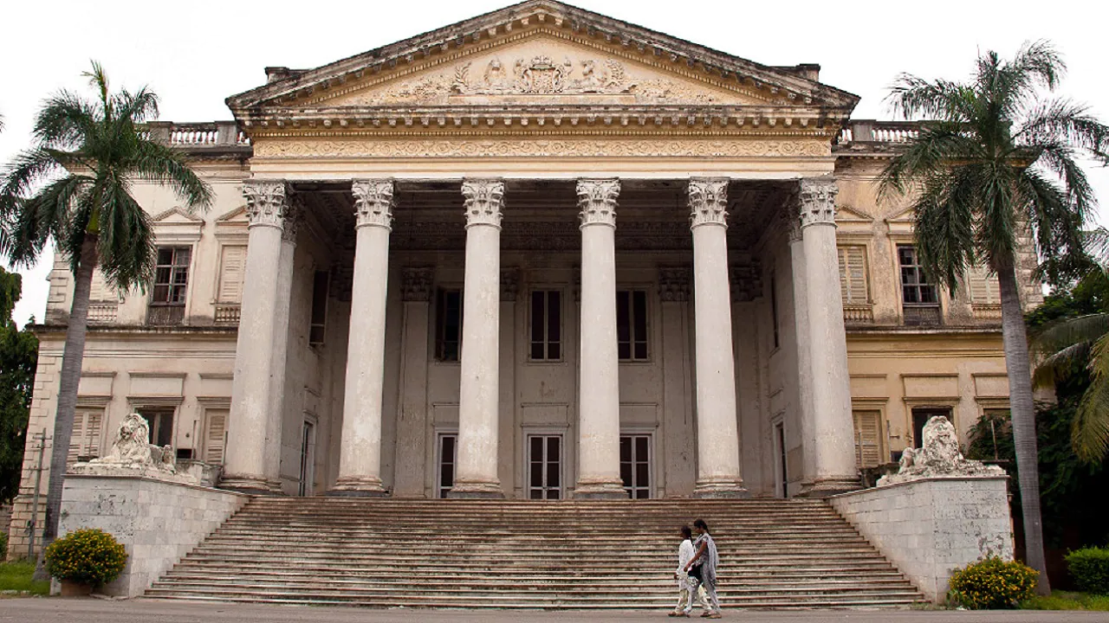British Residency North entrance

The historic structures belonging to the British period (1798-1947/48) are spread out on the northern banks of River Musi in Hyderabad, delineated as the Residency and Chaderghat areas under British control until 1933; as well as in the area north of Hussain Sagar tank where the British troops were stationed after 1798, the settlement ‘Secunderabad’ developed as a twin city of Hyderabad. The official residence and main offices of the British Residency constituting the core were the main three-storied Durbar Hall building and its extensions within a compound wall built after the Mutiny of 1857. Hashmat Gunj Gate, among other nearby structures stand outside of this wall. Today, except for the Durbar Hall building, many other historic structures within the core complex are still to be restored and are lying vacant.

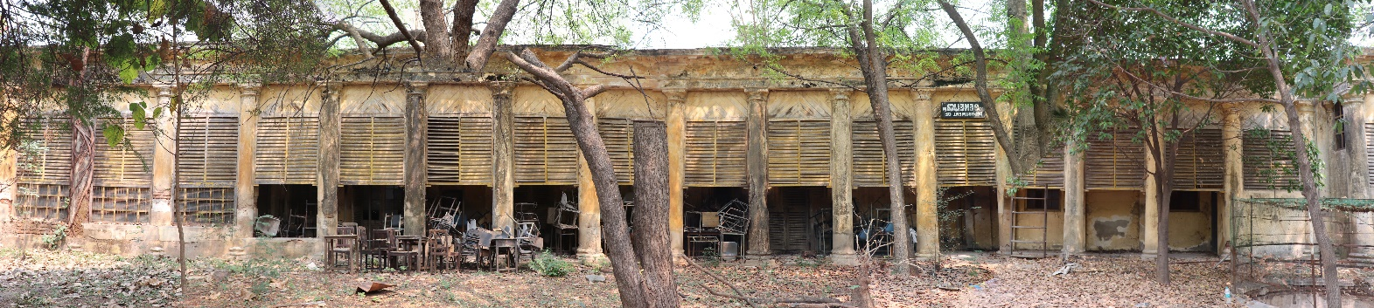

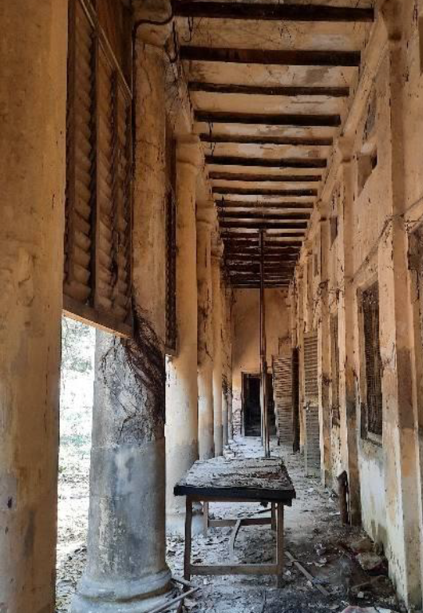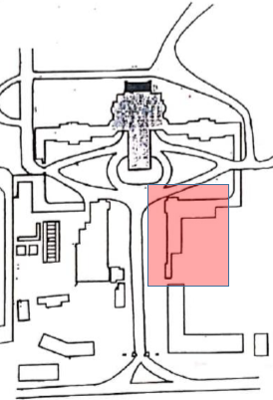

Residency physics block (original Residency offices) images and key plan (Vasaamaha, 2022)

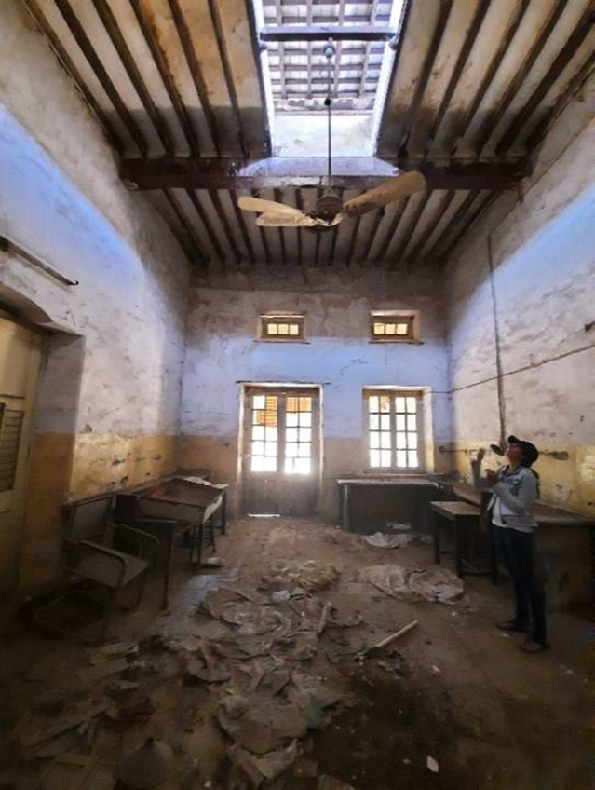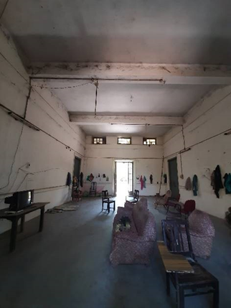

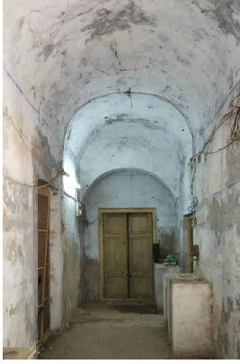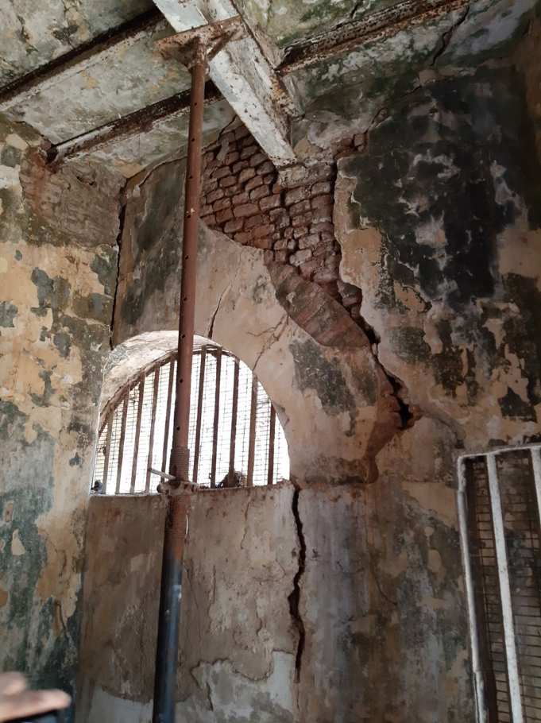

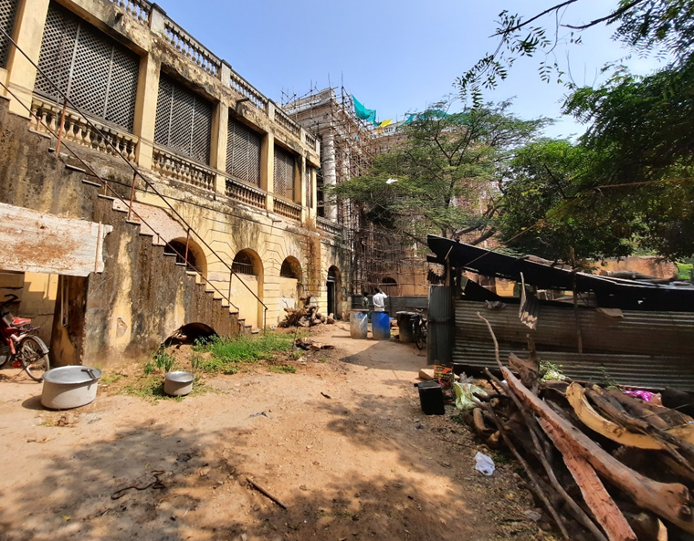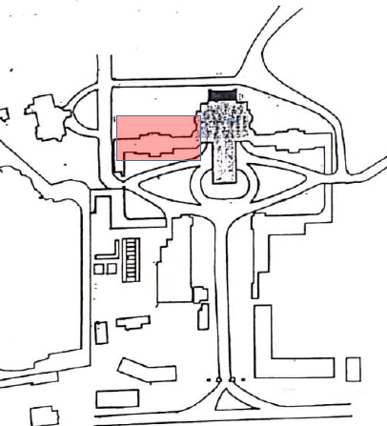
Original residential rooms of the British Residency, western wing used by restoration workers as quarters and kitchen (Vasaamaha, 2019)

Through the World Heritage USA (formerly US ICOMOS) Intern Exchange program 2023, Vasaamaha Consultants proposes an adaptive reuse design of the core structures of the Residency complex to make a Nizam-British Museum and Cultural Centre, with the aim of showcasing the entire Nizam and British colonial history and heritage of Hyderabad and Secunderabad, as well as its relationship to contemporary life and education. The objective of narrating this history is to express the historical significance of the entire British colonial area, i.e. the economic, social, and political dealings between the Nizam and British, which allowed for the prosperity of the Deccan area even to date; Recognize the opportunity to distinguish the Residency as a site for the greater community to engage with this complex history; and curate spaces which reconnect existing Nizam-British built structures accessible to the general public across the Deccan landscape, so as to relink heritage. Although a conditions assessment and restoration aspects are not in this project's scope, it is assumed that all Residency structures will be restored in entirety. The aim of this project is to provide space allocation and adaptive reuse possibilities.

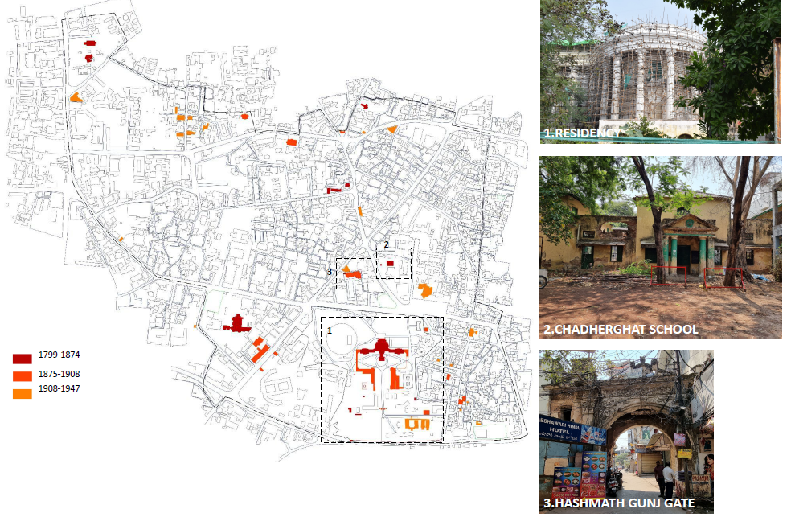Map showing zones identified for conservation plan (Image by Bindu Chandana, Thesis Report)

This research thus recognizes the Nizam-British contribution to the development of Hyderabad and Secunderabad, also known as the Twin Cities– a standpoint that is not always in alignment with the National narrative of highlighting the freedom movement against the British. Thus, discussion about heritage and preservation amidst contemporary livelihoods and social ideals are pertinent to this project, highlighting the challenges of aligning or rather not aligning the local histories to the National narratives.
In light of the aim, objectives, and scope, the design concept for the Nizam-British Museum and Cultural Center is three-fold; to express heritage as (1) a “bridge,” ensuring that the present day pays tribute to the past while also contributing to the future, (2) an “educator,” allowing for discourse and spaces to debate and overcome challenges of preservation within the University community, and (3) a “steward,” providing not only an example for sustainable preservation but a tool for future conservation efforts. This concept is further discussed in the subsequent sections.

Heritage as a bridge
- Exhibition spaces encourage further visits to significant sites
- Building additions speaking to history’s place today (particularly by paying
tribute rather than replicating the past)
Heritage as educator
- Spaces are designed for contemporary crafts created by students and visitors
- Spaces designed for discourse and conversation throughout the museum and
centre
Heritage as steward
- Recognition of the future of the museum and centre through flexible spaces
- Incorporation of a research wing that allows for restoration practices to be
taught

1.2 The History of Hyderabad

Hyderabad has a rich history evident in its streets today. The city of Hyderabad was founded in 1591 by the fifth sultan of the Qutub Shahi dynasty, Sultan Muhammad Quli Qutb, in the same year Charminar was started to be built by the sultan. For the purposes of this research, the period of interest is the Asaf Jahi rule which began in 1724 when Mir Qamaruddin Khan Asaf Jah I declared independence from the Mughals, thus ending the Mughal rule in the region of the Deccan Suba– encompassing today’s Hyderabad. The Nizam’s dominion of Hyderabad was quite extensive. Territorially he ruled a large state which was also a prime location for commerce and trade. The coastal area of Andhra where Masulipatnam was located on the eastern portion of the state, was an important port city that gave the state of Hyderabad its commercial power and brought colonial interest to the area. Such political and economic interests significantly defined the superiority of the state and the power of the Nizam.
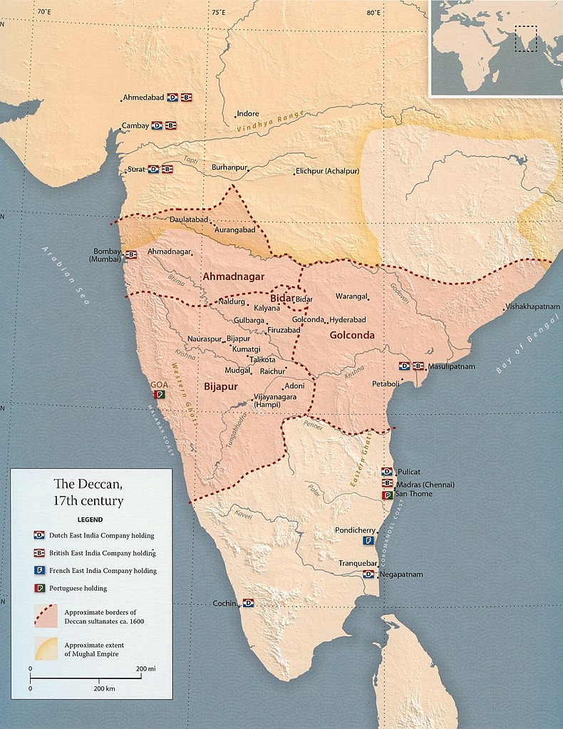
17th Century map of the Deccan. (2023. Wikipedia. https://en.wikipedia.org/wiki/Deccan)

From the origins of the Nizam rule, and during Nizam-ul-Mulk, Asaf Jah I’s rule of Hyderabad State, comes the colonial era, which begins to show a dynamic change in the urban and political makeup of Hyderabad amidst the Anglo-French struggle for power from 1750 to 1798.
Having first been controlled by the French, Hyderabad’s British presence formally began through a subsequent treaty in 1779, which appointed a British ambassador to Nizam Ali Khan's court. This officially initiated British rule with the appointment of the Residents as British officials who represented the alliances between the local ruler and the British crown or East India Company at the time headquartered in Calcutta (today’s Kolkata). There was a total of 79 residents spanning 167 years who initially delegated the rule of the East India Company (See Appendix I), a trading company turned colonial tool, to the Nizam in Hyderabad. Thus, the first Resident, John Holland, began the consistent presence of the British in the district under the Monarchy of Nizam-ul-Mulk, Asaf Jah I. The Subsidiary Alliance of 1798 was signed during the appointment of the 6th resident, James Achilles Kirkpatrick, and thus began the British East India Company's sole occupation of the area.

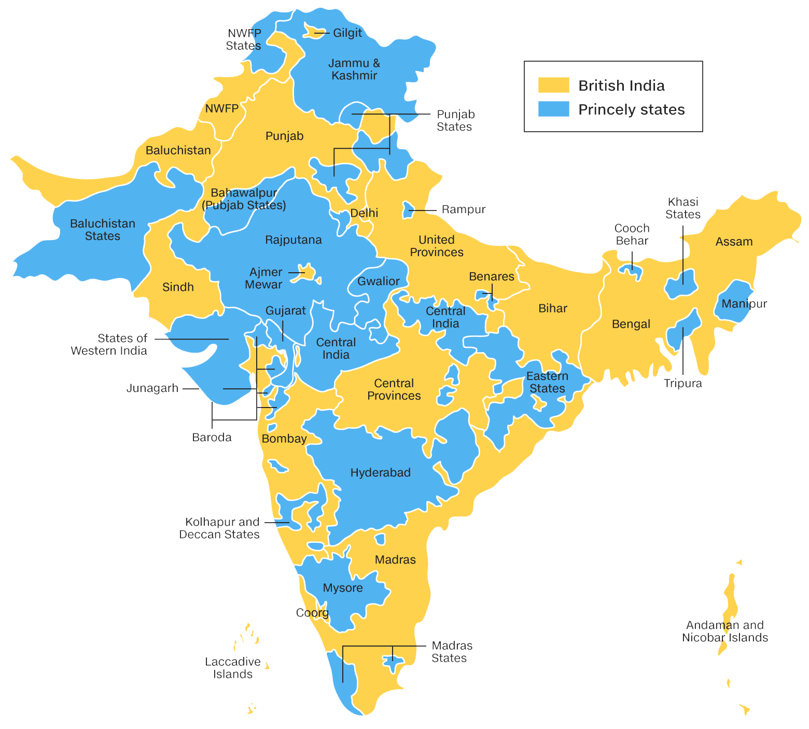
British India and Princely State Map (Rathore, Abhinay. “Rajput Princely States.” Rajput Provinces of India. https://www.indianrajputs.com/princelystates.php.)

1.3 Defining Hyderabad and Secunderabad

The tangible history of the British-colonial era in Hyderabad began in 1798 with the commission of the British Residency building by Achilles Kirkpatrick, the 6th resident of Hyderabad proceeding his brother. Kirkpatrick was perceived as a personable man to both his Englishmen and the Indian leadership. In fact, under his leadership, the French surrendered after the British Subsidiary agreement with no bloodshed. For this success, he was made the aide-de-camp to the Governor General. He also earned the title of “Hashmat Jung” meaning “magnificent in Battle” by the third Nizam, Mir Akbar Ali Khan who also gifted land located just north of the River Musi and the Nizam’s Palace for a Residency building. Approximately 60 acres of land according to Davie Phillip was gifted and the building was paid for by the Nizam and designed by Samuel Russell of the Madras Engineers. Kirkpatrick commissioned this permanent building in 1803 as well as a Zenana for his controversial love, Khair un Nissa, a descendant of the Nizam at the time.
The primary structure, the Durbar Hall, was designed in the Palladian style. It was completed in 1806 just a year after Kirkpatrick’s death in 1805, yet its further development was continued by subsequent residents. At the time its surroundings featured a Chaderghat (shops and residences) owned by the British, banks, among other main entities in the bazaar. The building has been defined as an “architectural expression of supreme power intended for political ends” (Davies, 95). Similar to the culture of the area and period, wealth and power were expressed outwardly, even on the built form.
The 1798 Subsidiary Alliance also initiated the development of Secunderabad, a city whose colonial heritage parallels that of Hyderabad. Secunderabad was originally named the Lashkar Contentment but was renamed after the reigning third Nizam, Mir Akbar Ali Khan (Sikandar Jah Asaf Jah III) in 1803 under the Residency of Thomas Sydenham (8th resident) who requested the name change. The city is located northeast of the Hussain Sagar Lake and from 1789 onwards served as the camp of over 5000 British soldiers stretching 4 sqkm at the time of its founding.

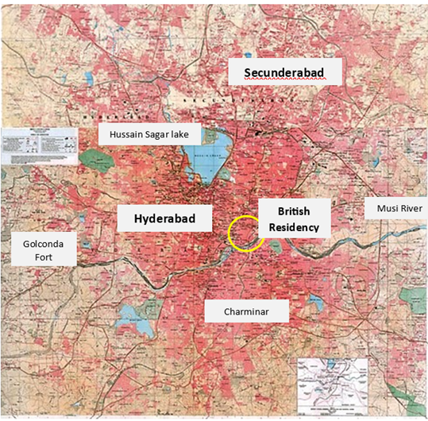
Map featuring Secunderabad and Hyderabad’s parallel development (Vasaamaha)

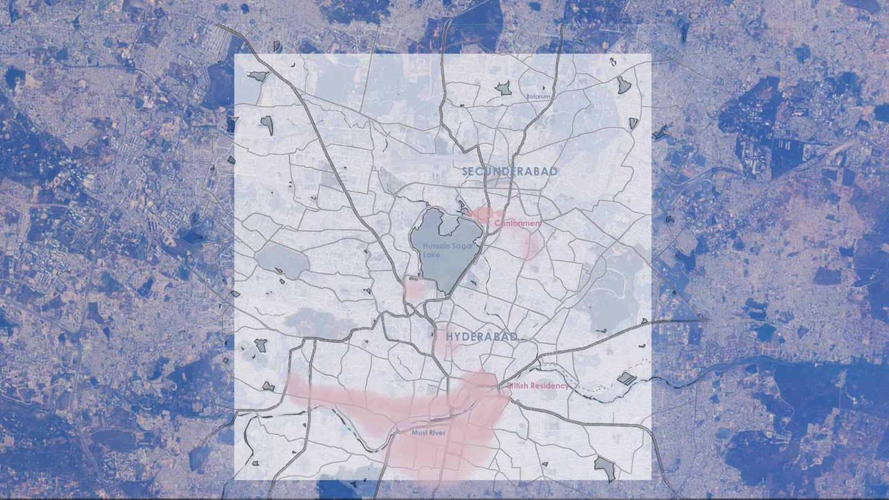
1798 Secunderabad and Hyderabad parallel development (Image by author)

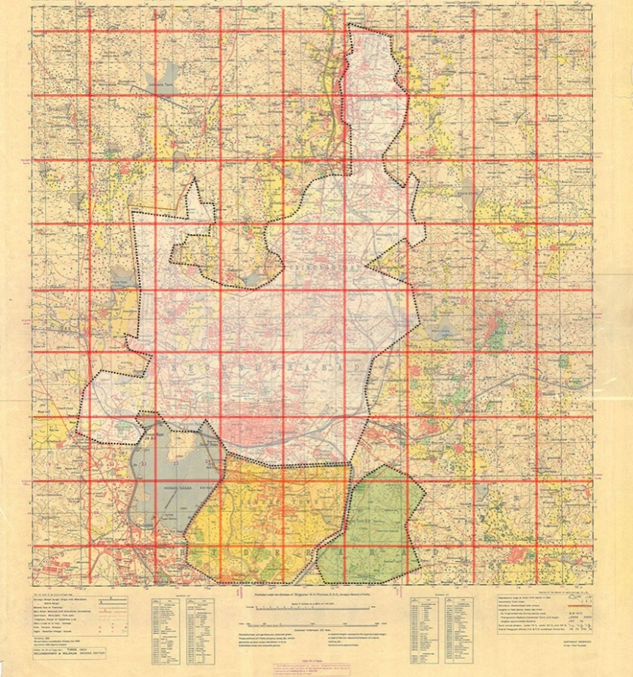
Boundaries of Secunderabad areas marked on Survey of India Map (Vasaamaha)

The Secunderabad Cantonment is where the military functions of the state took place. Originally a tent city, the cantonment area was meant to spread a considerable distance north to Bolarum. The confinements of the late 1700s moved existing British troops away from the main city streets, to rural areas. Thus, it separated the government from the people it governed, showcasing the “characteristic of the Raj” according to Davies Philip, which may serve as a symbol of dissonance, but did provide considerable availability of land for growth which encompassed the indigenous population. The bazaars associated with the British crown, particularly troop bazaar in the Koti area sustained much of the economics of the everyday civilian. The permanence of British military presence necessitated the building of a new typology which shifted the character of Hyderabad and Secunderabad respectively. Churches, bungalows, buildings associated with social clubs and leisure activities, as well as new landscapes became a part of the culture of the twin cities. The parallel development of Secunderabad and Hyderabad is notable for a holistic understanding of British presence.
Hyderabad itself encompasses such interventions which showcase both the European styles constructed by Indian contractors and craftsmen. This leads to a fusion of indigenous and foreign architectural expression.

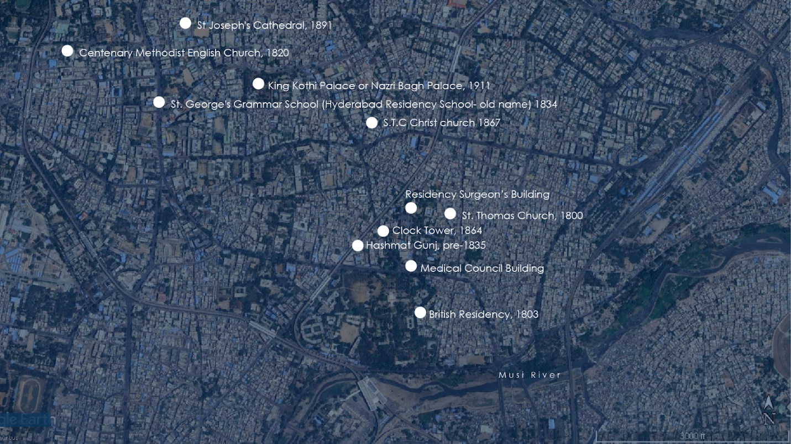
Colonial Structures in Surrounding Residency’s Chaderghat area (Image by Author)
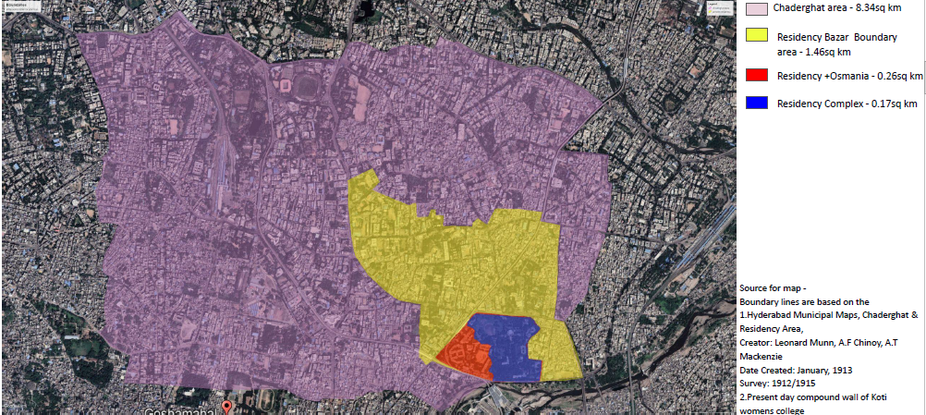
Map of Boundaries of Hyderabad and Different Areas (Image by Ar. Bindu Chandana)

Among such colonial structures is the Hashmat Gunj Gate, a pre-1835 structure with the East India Company insignia located near the Sultan Bazaar area. As part of the fabric of the Sultan Bazar area, the Gate is currently being encroached on by civilian shops.

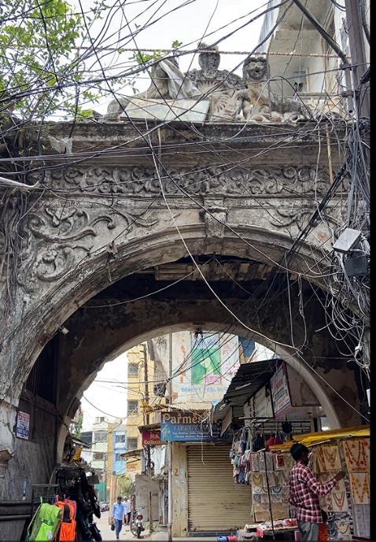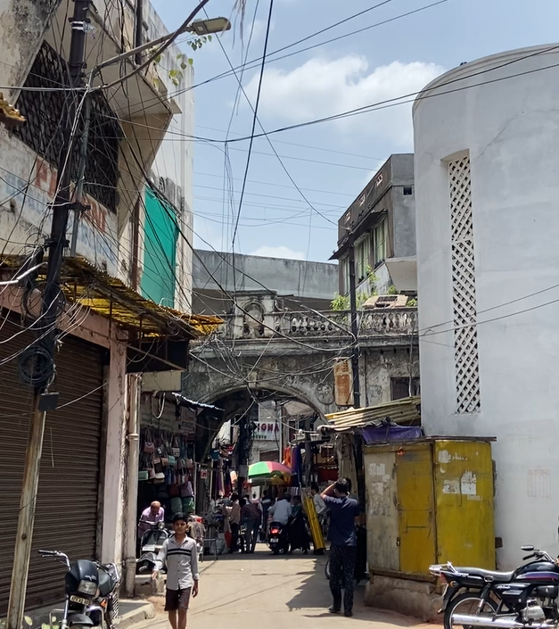
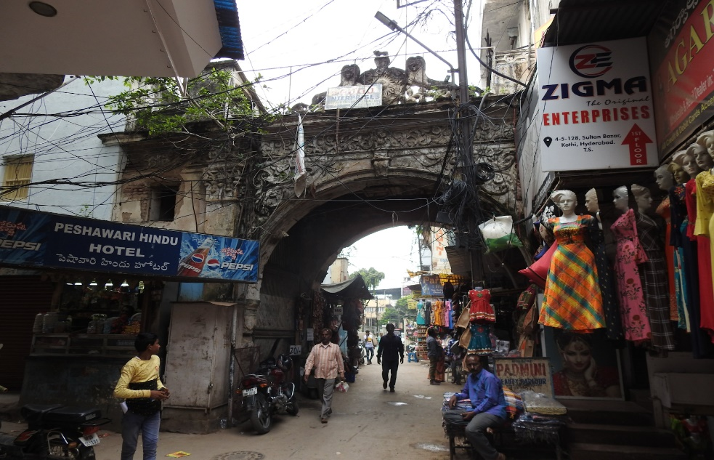
Images of Hashmat Gunj Gate, 2013 (Images by author)

1.4 Preservation of the British Residency Today

The British Residency was Listed as Heritage Building Grade IIB under the Hyderabad Urban Development Authority Heritage Building Regulations 1995. In 2006, by a Public Interest Litigation appeal by Vasaamaha to the High Court of Andhra Pradesh to accord a National Protected Monument status on par with the Lucknow British Residency, the Hyderabad British Residency was declared a State Protected Monument.

Other key players in the heritage designation, protection, and maintenance in Hyderabad include:
- The Department of Heritage Telangana
- Greater Hyderabad Municipal Corporation (GHMC)
- Hyderabad Metropolitan Development Authority

The redesignation of the Residency as a Museum and Cultural Center also addresses questions about the Monument’s authenticity. Interestingly, along with the 2002 designation by World Monuments and in light of its ownership of the structure by Osmania University College for Women, the Residency was designated under the title of Osmania University College for Women. The misnomer is further discredited by the recent renaming of the University to Mahila University in 2022. Under the tenant of preservation by UNESCO, there is also a responsibility to currently connect the Residency to its original use or sentiment. Though simple, the renaming of the Monument to the Nizam-British Museum and Cultural Centre seeks to do just this.
As a continuation of this preservation process. Vasaamaha Consultants and team are proposing to do a heritage zone within the university campus, which preserves the historical significance of the building within Hyderabad’s colonial history, while also placing it in conversation with the University community.
The Nizam-British Museum and Cultural Centre also acknowledges the fact that there is currently no city museum within Hyderabad which speaks to the city’s development by notable figures of the city. There exists a number of museums that showcase the vast craftsmanship and collections of such figures, yet their contributions to the city itself are not fully expressed.

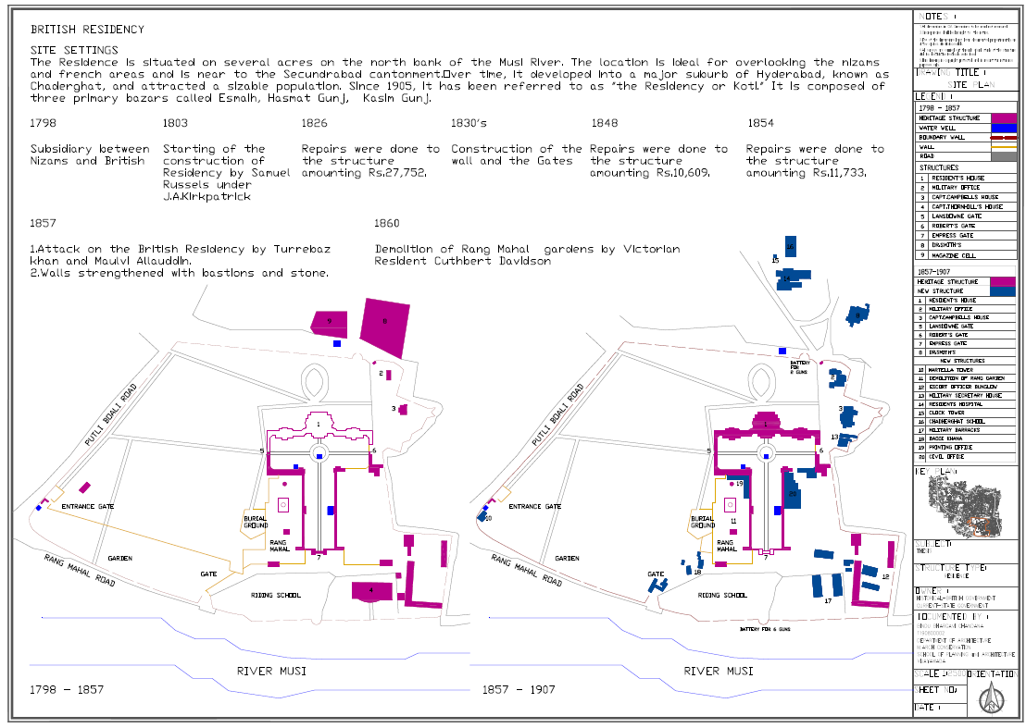
Image showing development of British Residency over time (source, Ar. Bindu Chandana)

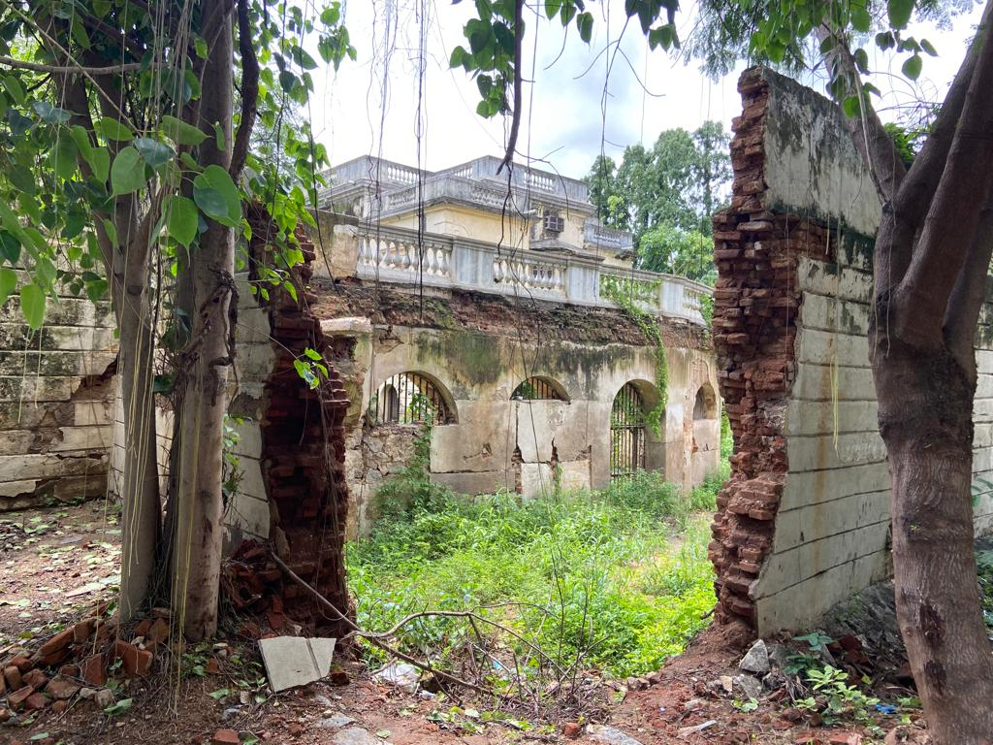
Existing Eastern wing (image by author, 2023)

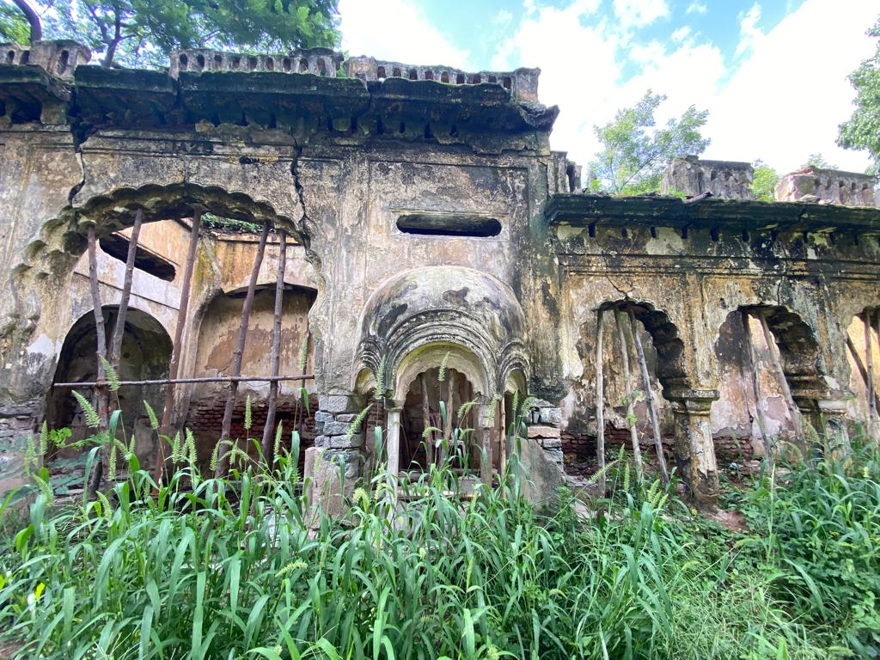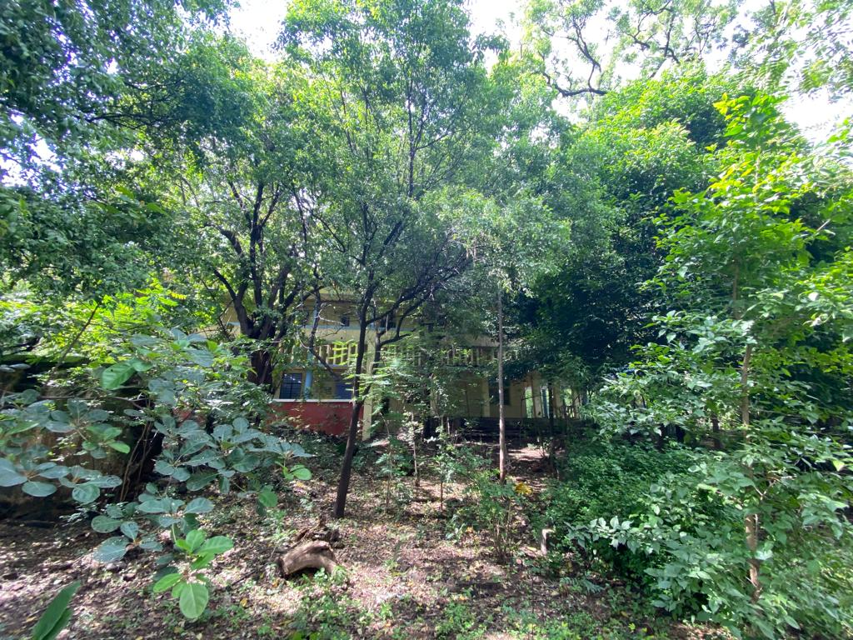
Existing southwest garden area (image by author, 2023)

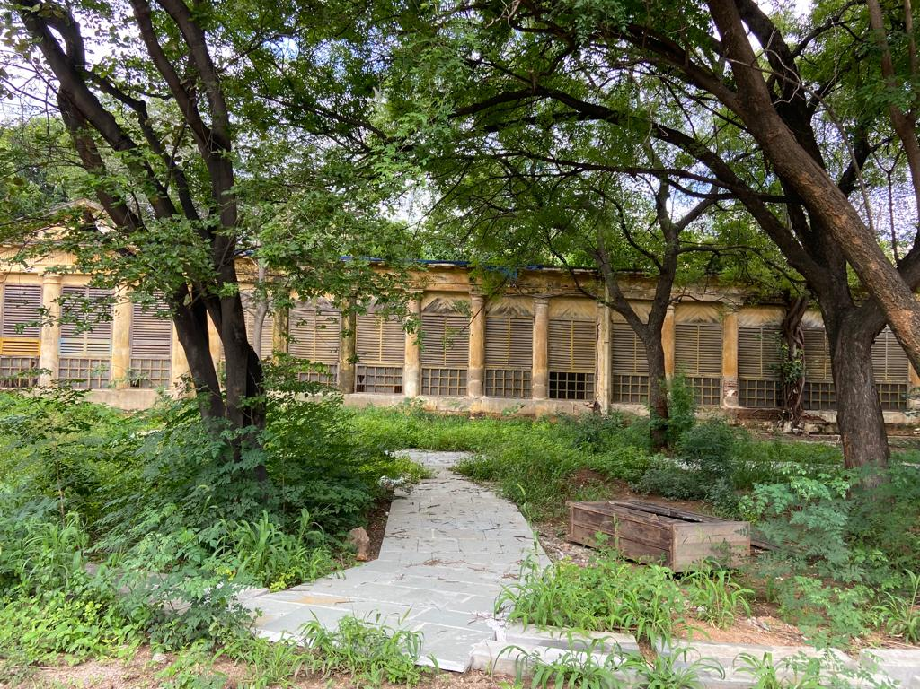
Existing physics block (image by author, 2023)

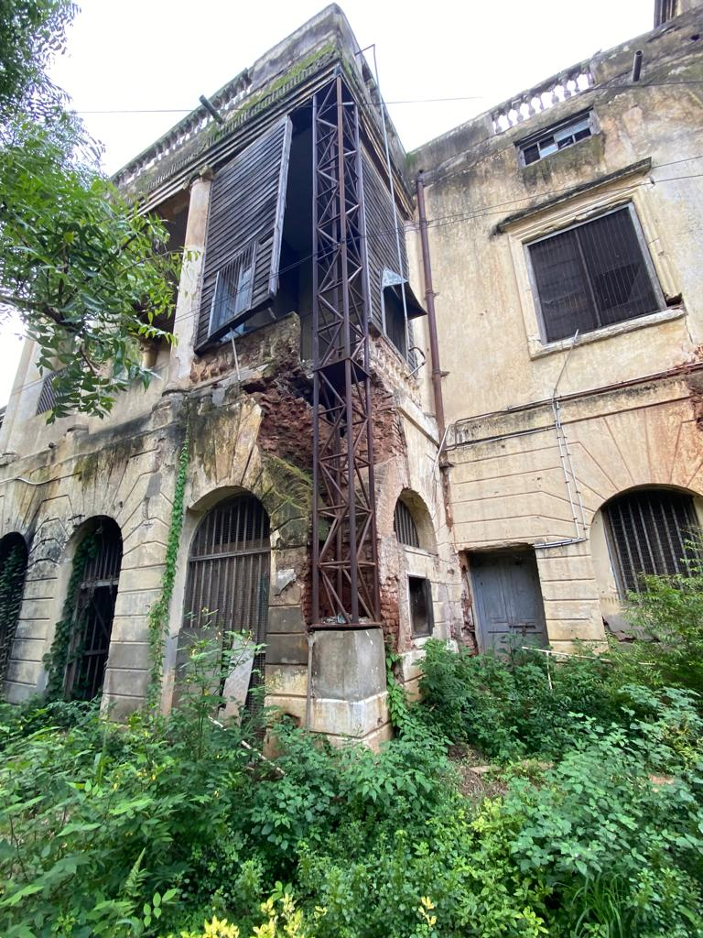
Existing western wing (image by author, 2023)

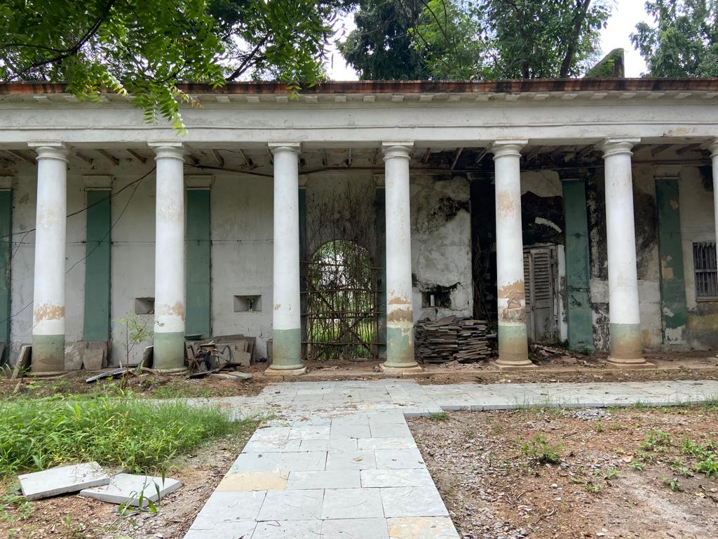
Existing chemistry block (image by author, 2023)

2. DESIGN PROPOSAL

2.1 Defining the Heritage Zone, Museum, and Cultural Centre

Heritage is generally defined as tangible and intangible history that defines a culture, place, and/or time period. Cultural heritage is defined by ICOMOS as monuments, groups of buildings, or sites with a universal value that points individuals to a particular anthropological, ethnological, or historical point of view. The International Council for Museums (ICOM) defined the museum as “a permanent institution in the service of society that researches, collects, conserves, interprets and exhibits tangible and intangible heritage…. [museums] operate and communicate ethically, professionally and with the participation of communities, offering varied experiences for education, enjoyment, reflection and knowledge sharing.”
In light of such definitions, the preservation of cultural heritage acknowledges the inherent value of sites, buildings, and monuments constructed during a significant historical moment. The Colonial structures built during the British protectorate express such value. The British Residency building, located in the Koti area of Hyderabad, is of particular importance as it represents the beginning of the tangible heritage of the colonial era. In order to both represent this significance and advocate for further restoration, I have proposed an adaptive reuse museum design for the British Residency, which seeks to honor an expansive Nizam-British history and reconnect existing colonial architecture back to the site. Through this proposal, the intangible heritage of Hyderabad is expressed throughout its tangible heritage.
The first step in this process has been made through designating the area as a Heritage zone, or a site important to the culture of an area., through Vasaamaha Consultants. This zone encompasses the original Residency complex. The design proposal below supports this designation through its concept of expressing heritage as a “bridge,” ensuring that the present day pays tribute to the past, an “educator,” allowing for discourse and spaces that engage with the Mahila University community, and a “steward,” providing not only an example for sustainable preservation but a tool for future conservation efforts.

Map of Boundaries of Hyderabad and Different Areas, blue indicating the Residency complex (Image by Ar. Bindu Chandana)

2.2 Methodology
A thorough literature review on the British and Nizam relations during the 1779-1948 period, site visits to relevant structures–museums and places of historic significance specifically, and interviews with experts on the cultural heritage of the Deccan region, encompass the research tools which support this report. Information has been gathered and organized within the span of 2.5 months by the World Heritage Intern Exchange Program, though the research itself began through Vasaamaha Consultants prior to the 2023 project. This adaptive reuse project necessitated an in-depth and immersive experience of the culture of Hyderabad and the greater Deccan region.
Through such research and the pertinent design concept of heritage as bridge, educator, and steward, the following design has been proposed for the Nizam-British Museum and Cultural Centre.

2.3 Writing the Museum Narrative

2.3.1 Site Proposal
The sight of the Nizam-British Museum and Cultural Centre creates connections to the existing colonial-era structures as well as contemporary establishments which add to the vibrancy of the Koti area in Hyderabad. This is done physically by activating a minimally used subway that crosses Koti Women’s College Road. This subway connects the southwestern block of the Sultan Bazaar area, originally the Residency Bazar area where the Hashmat Gunj gate currently sits in disrepair, to the campus of Mahila University and the Nizam-British Museum and Cultural Centre. This area features bookshops, which also operate at the entrance of the subway, thus, this additional use will further highlight the shops. Utilizing the subway revitalizes an existing civilian amenity while also serves as a method of access to the Centre. From the Northwest portion of the campus, students, visitors and researchers alike can experience a historic walk through the gardens, before making it to the main entrance.

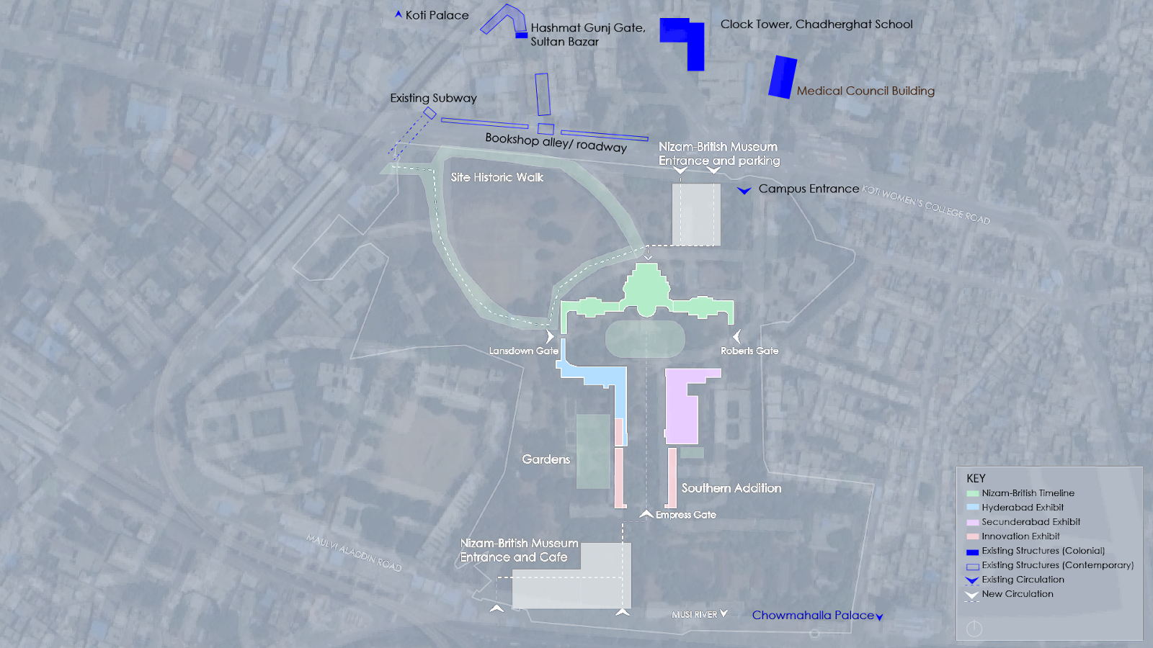
Site proposal for Nizam-British Museum and Cultural Centre (Image by author)

Additional entrances to the campus grounds have been added to support the new Centre. The northeastern entrances are parallel to the university’s existing entrance, yet welcome guests into an area for parking and visitor facilities. A visual grill fence is also proposed for public viewing. The residency is not currently visible from Koti Worn’s College Road due to an additional stone fence. Removing this fence allows for visual access which showcases the museum and represents the need for accessibility for all. On the southwest, additional entrances are designed which encourage a connection from the Musi River. Along with the proposed entrance is a cafe, named the “Rang Mahal Cafe” in honor of the original woman’s quartered (zenana) constructed just north of this, as well as shops for guests, which also seeks to support the university community.

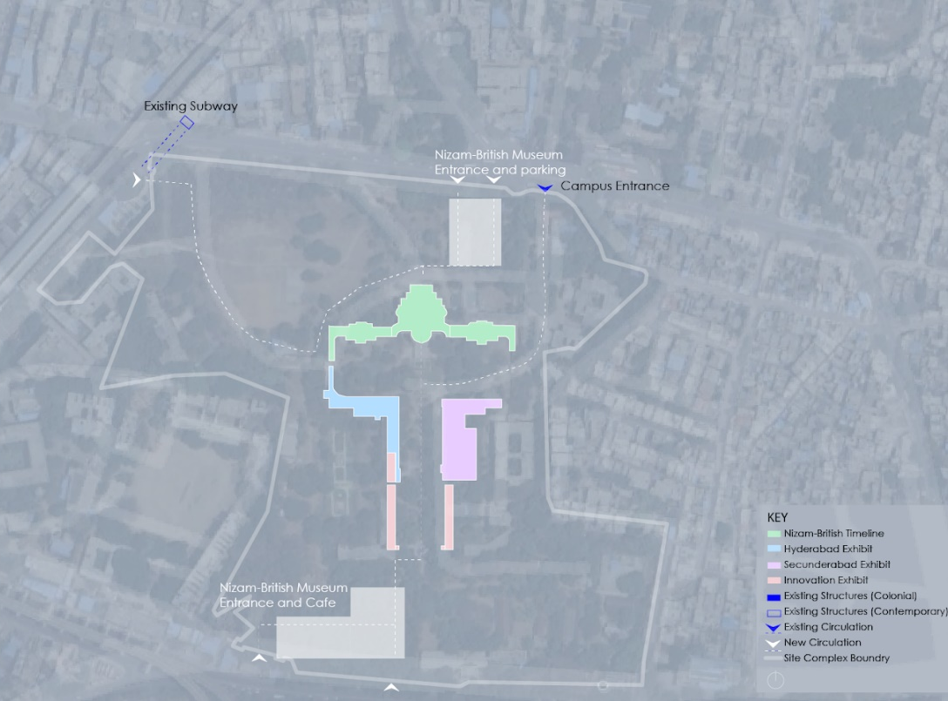
Nizam-British Museum site map displaying entrances (image by author)

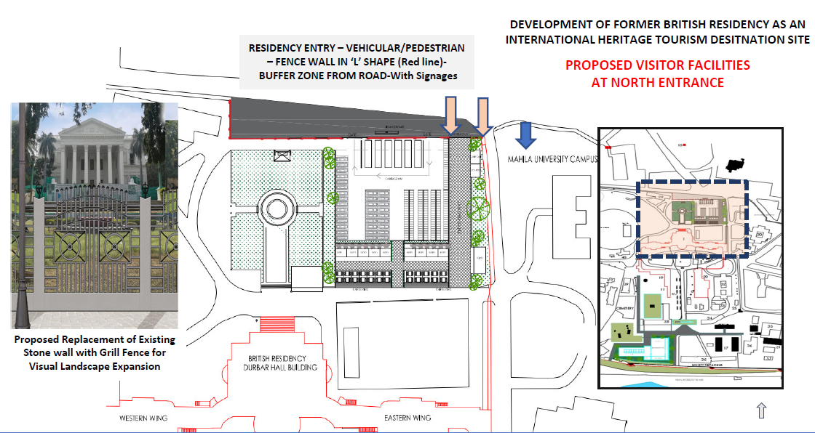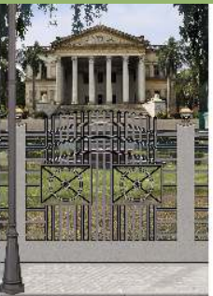
Site Design Proposal for Northern Campus Entrance and Parking and Visitor Facilities (Shops, Rest Rooms, Drinking water, Ticket counter, Clock room and visitor information centre (Vasaamaha)

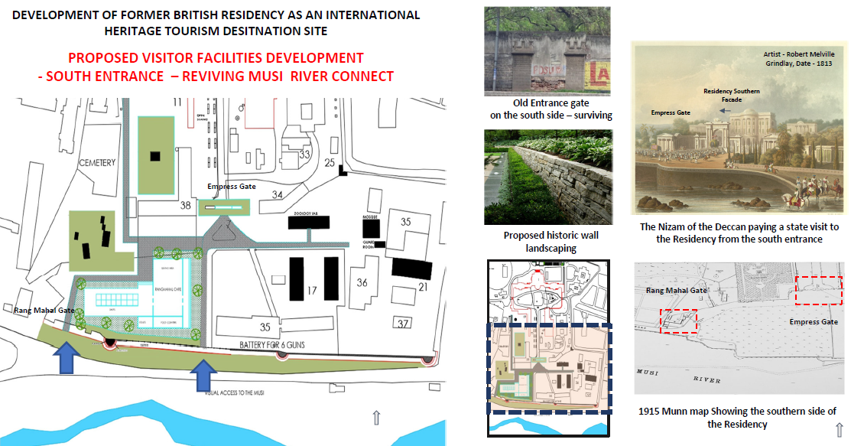
Site Design Proposal for Southern Entrance and Rang Mahal Cafe (Vasaamaha)

Opening the southern portion of the site pays tribute to the original Nizam entrance, from his own palace, just south of the Musi River. This connection to the Musi River patronized the ceremonial entry from the Empress Gate, distinguishes the Rang Mahal and the miniature building model west of the building, the restored cemetery, and recognizes the surviving 1857 wall with bastions and closed gates. It also encourages visitors and civilians to explore the vast exterior of the Centre.

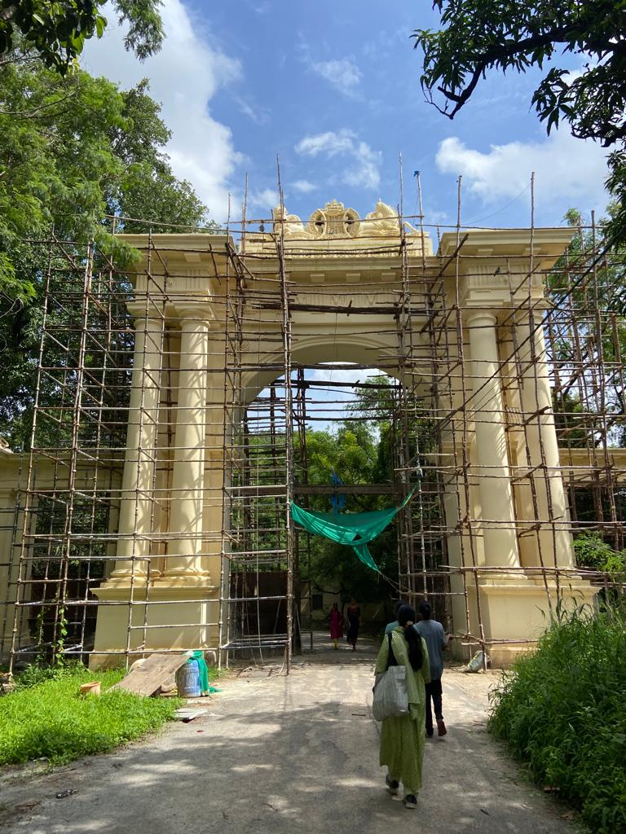
Empress Gate today (Image by author, 2023)

2.3.2 Building Proposal
The building itself is divided into four broad sections. The three-storied Durbar, as well as the two-storied East and West Wings, hold Historical timeline exhibitions, allowing the visitor to experience the full extent of the Nizam-British history. The Southwestern wing, commonly referred to as the chemistry block, pertains to the story of Hyderabad. Adjacent to this section is the Secunderabad history block in the Southeast. The southernmost sections hold exhibitions of technological advancement over time as well as contemporary narratives of innovation, craft, and technology. In alignment to the concepts of heritage as a bridge, educator, and steward, the proposed design of each section is sensitive to highlighting contemporary conversations through heritage, encouraging discussion through the university, and speaking to a sustainable culture of preservation efforts.

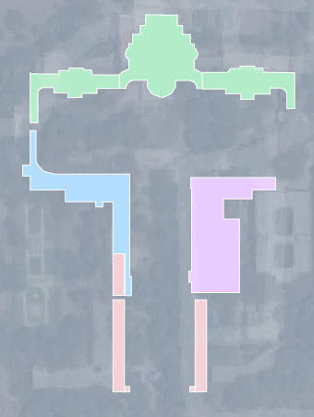
Building Proposal Zoning and Key (drawing by author)

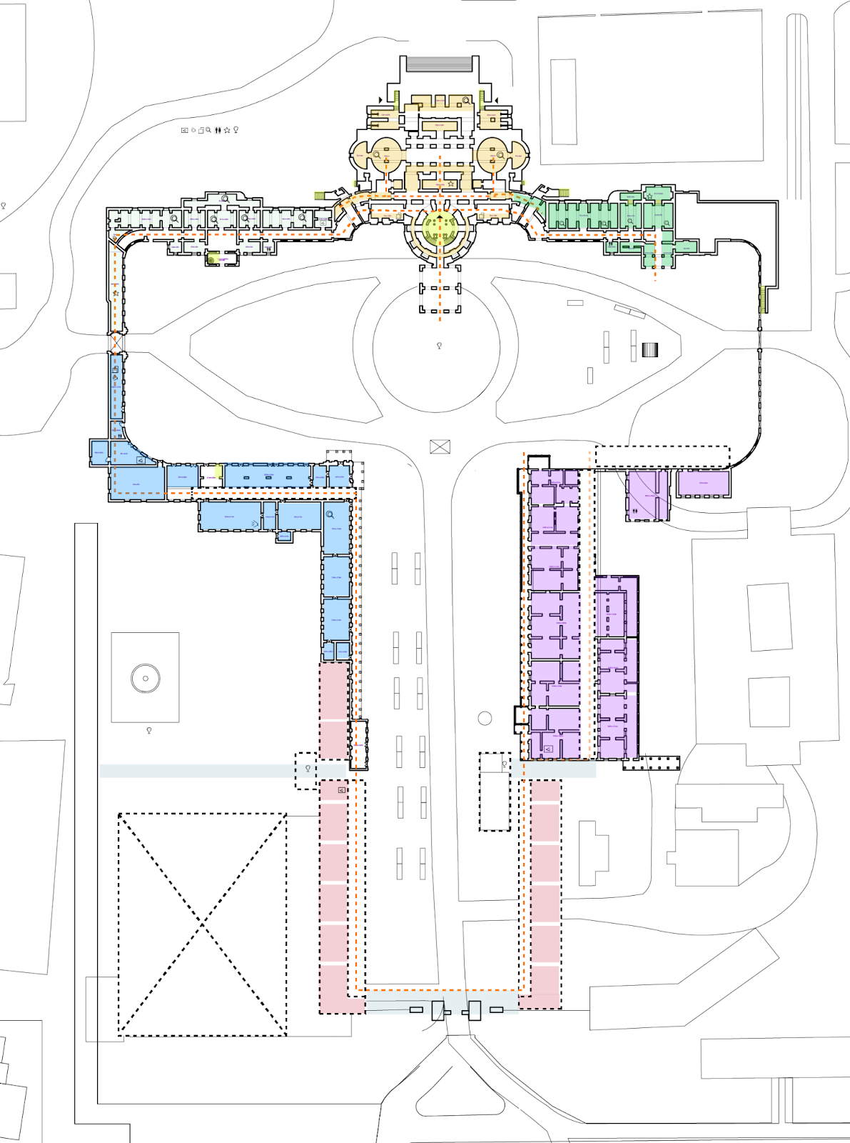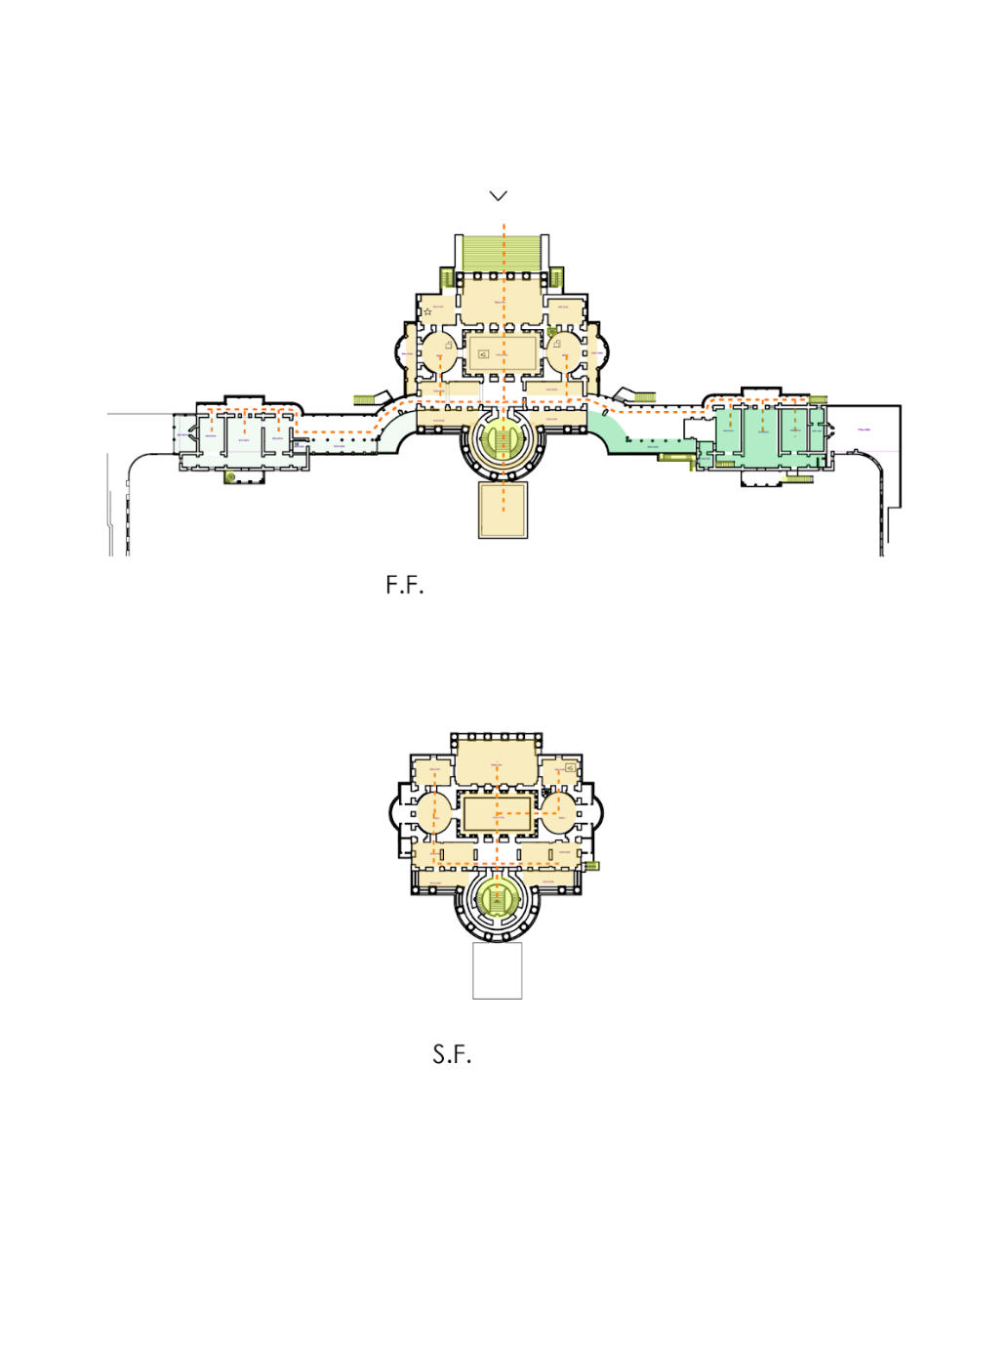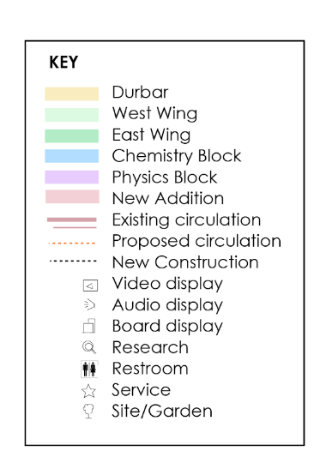
Nizam-British Museum and Cultural Centre Floor Plans (by author)

The main section, the Durbar Hall features the main visitor entrance on the first floor of the building. This section primarily highlights the introduction to the pre-built (1725 to 1798) history of the British-Nizam relations which showcased a vast number of political actors, preceding in various districts or villages with distinct agendas and shifting alliances. Urban development took place from the onset of the Nizam period in 1725 to 1798, when the first British Resident took office, physically, in Hyderabad. Thus, we can turn to this pre-built period as one of which composes the necessary relationship between the British Crown and the Hyderabadi Monarchy politically, physically, economically, and socially.

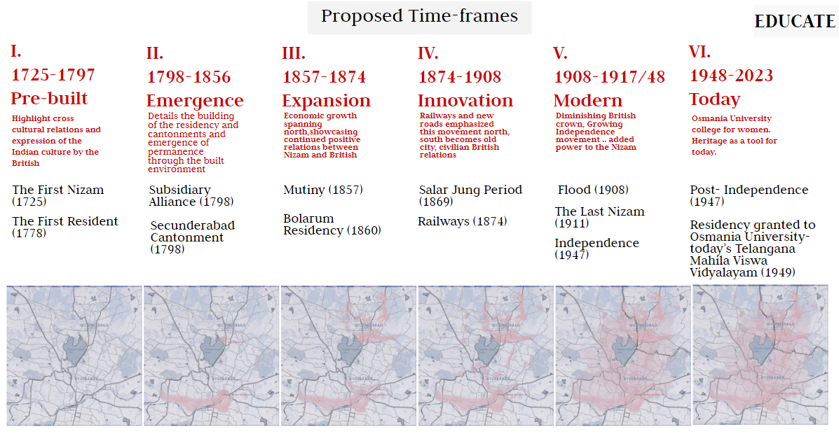
Proposed Historical Timelines (Image by author)

During the colonial period, the Durbar was used as a hall for hosting guests for dinners and dances. As a bridge to this original use of the main entry space, a portion of the first floor Durbar is used for the contemporary performances and showcasing crafts of Hyderabad today. The corridors exhibit the recent restoration efforts done in this primary section of the British Residency building.

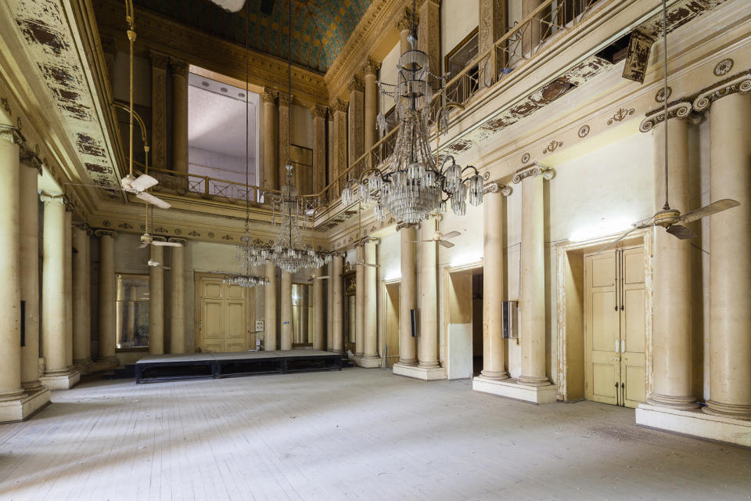
Durbar Entrance Hall (Image by Grégoire Cachemaille)
Dance Hall Render (by author)

The top floor of the Durbar tells the story of Hyderabad and Secunderabad post-Independence, while the ground floor features the administrative spaces and utilizes the southern entry for the Cultural Centre.
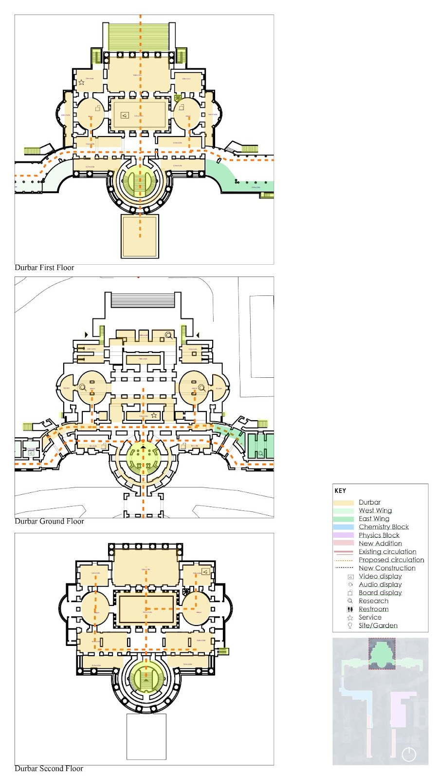
Durbar Hall First, Ground and Second Floor Plans (Drawings by author)

The first floor of the western wing features the Emergence Period exhibitions which include the timeline of 1798-1857, defined as a period of emergence for both Hyderabad and Secunderabad. The ruling Nizams include Mir Nizam Ali Khan Siddiqi, Asaf Jah II (the second Nizam, ruling from 1768-1803), Mir Akbar Ali Khan becomes Nizam (third Nizam, 1803-1829), and Mir Farquanda Ali Khan becomes Nizam (fourth Nizam, 1829-1857). The tangible history of the British in Hyderabad began in 1798 with the commission of the British Residency building by Achilles Kirkpatrick, the 6th resident of Hyderabad proceeding his brother. Kirkpatrick was perceived as a personable man to both his Englishmen and the Indian leadership. Thus, this section highlights the personal stories of the residents and their transactions with the Nizam.
This section encompasses a gift shop that utilizes the vernacular bazaar seen across the region. This celebrates local culture and supports the local economy.
The ground floor supports the research centre and the Expansion time period of 1857-1874. This time period may be defined as a time of expansion. Economic growth and shifting relations among the British, Nizam, Salar Jung I, and civilians showcase the continued positive relations between Nizam and the British. The Mutiny of 1857 is the most pertinent event of the era. The Mutiny seemingly contrasts the friendly relations of the British and civilians Nationally, though in Hyderabad this initial war of independence was relatively small. The experience of the Mutiny with be exhibited in this section to showcase the uprising among sepoys, Indian troops, trained under the British, and eventual Independence heroes.

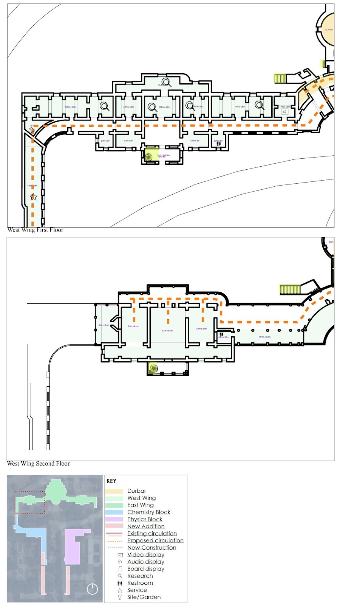
The Western Wing First, Ground Plans (Images by Author)

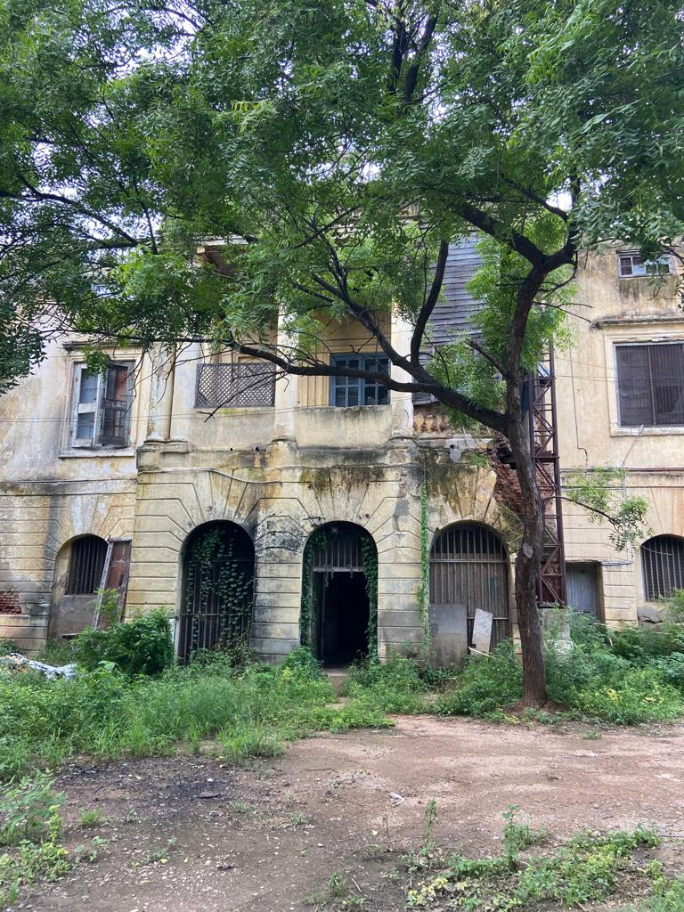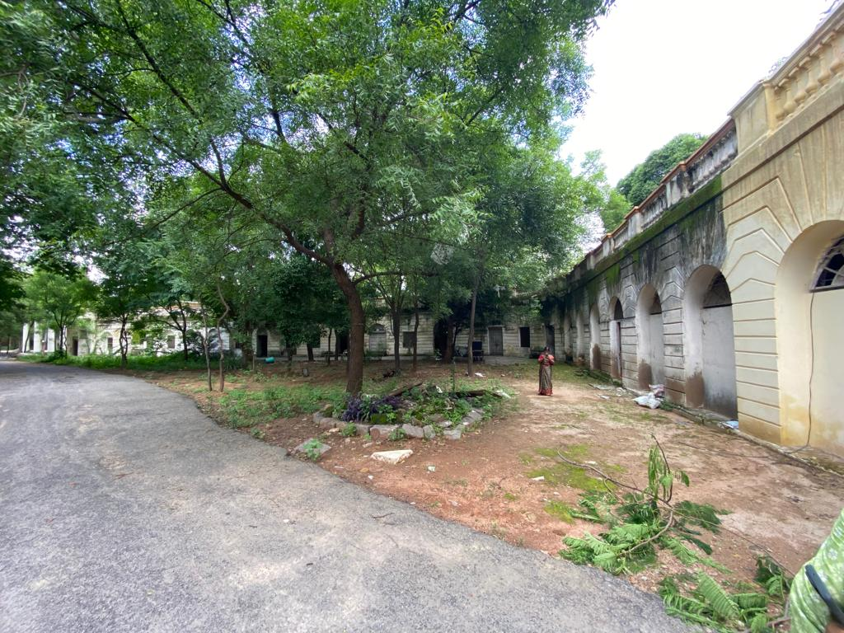
Existing Western Wing (image by author)
Bazar/Shop Render (by Author)

The eastern wing showcases the Modern Period on the first floor which also incorporates the library and reading rooms for the general public. The ground floor level constitutes an administration and storage area for museum archives and rotations.

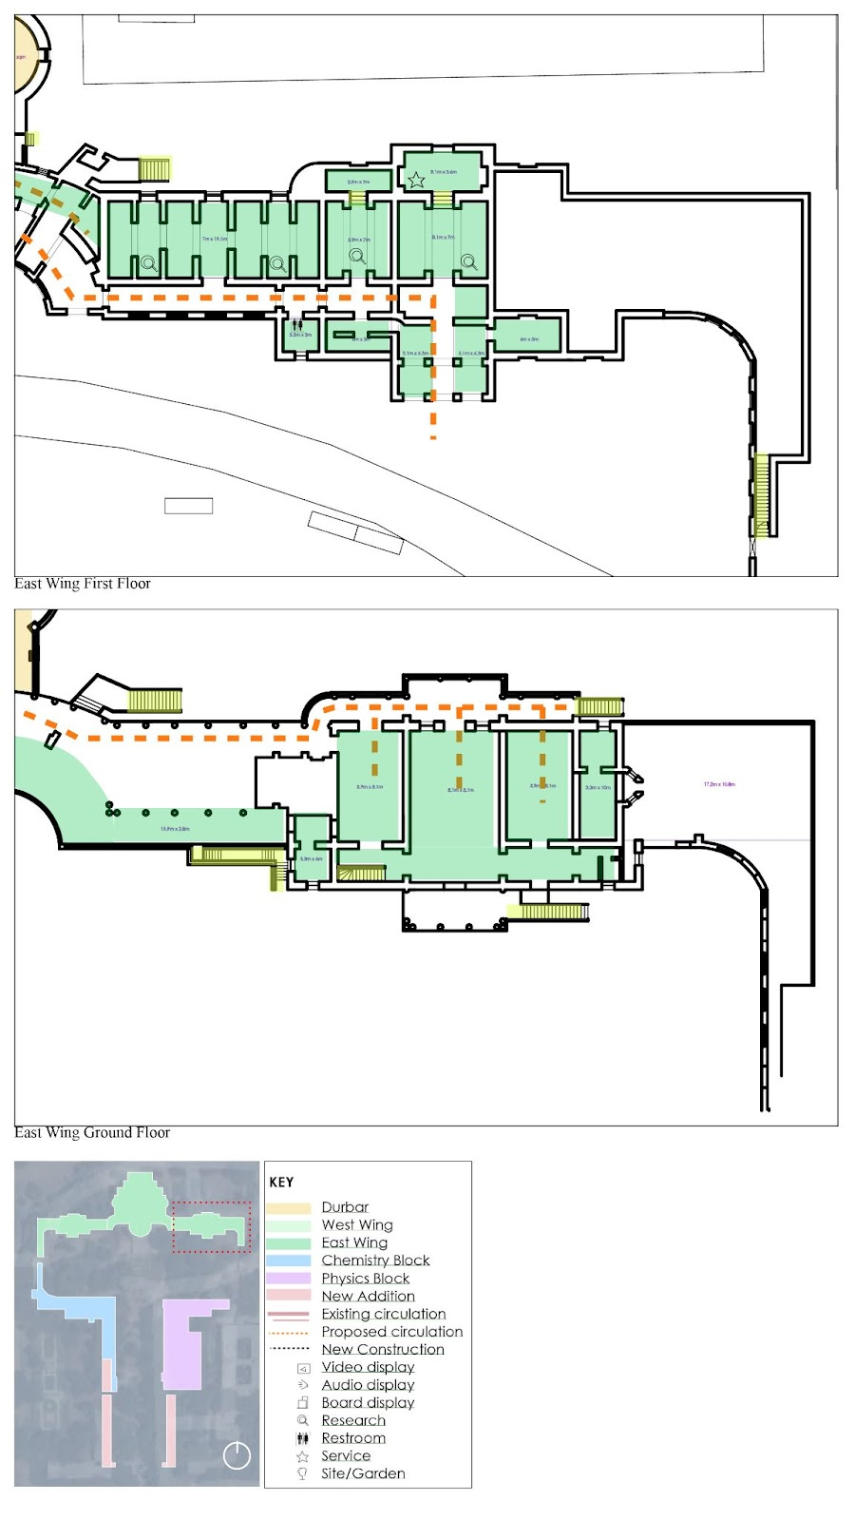
Eastern Wing First, Ground Floor Plans (by author)

The building is accessible through the north for visitor entry, yet the visitor is able to access sections of the museum, which encompass the 5 primary sections. The additional amenities– the dance and music hall, library, and bazar, are accessible from the north entrance for ease of use when the museum facilities are closed. The southern entrance is for the researchers and administrative staff to access the facilities at various hours of the work day.

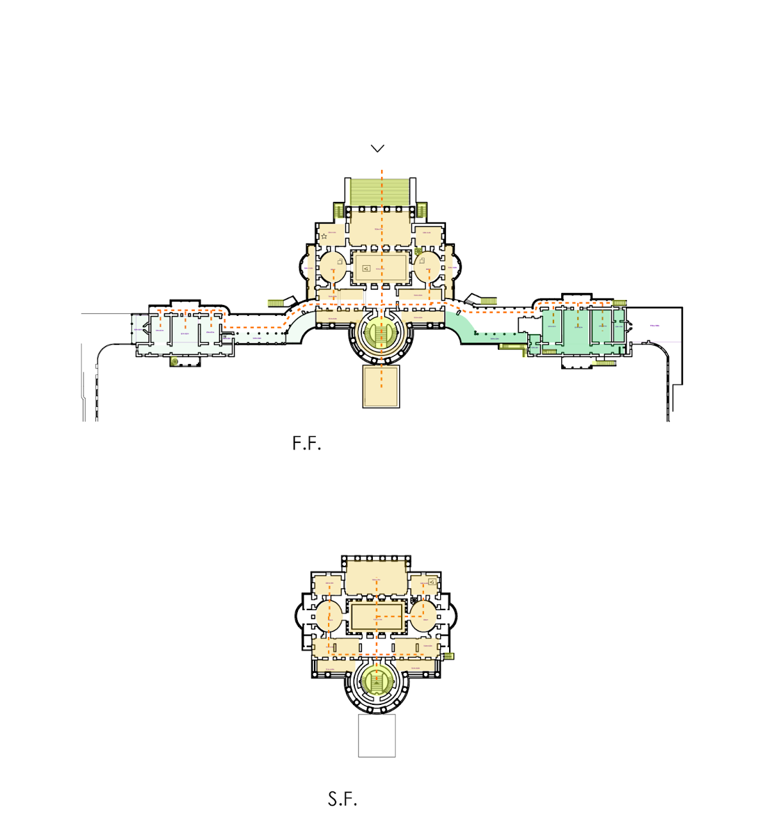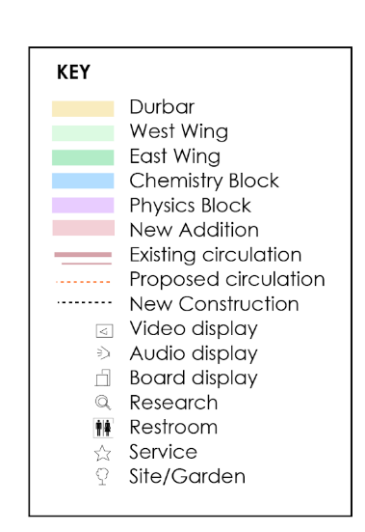
Circulation plans (by author)

The Secunderabad and Hyderabad sections of the building, originally termed the physics and chemistry blocks respectively, celebrate the growth of the twin cities.

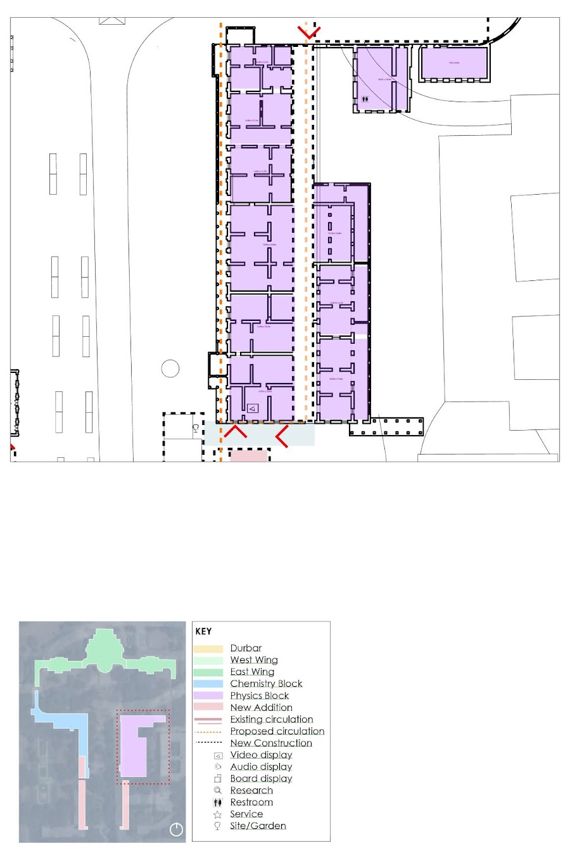
Secunderabad Exhibition Space of Nizam-British Museum and Cultural Centre (by Author)

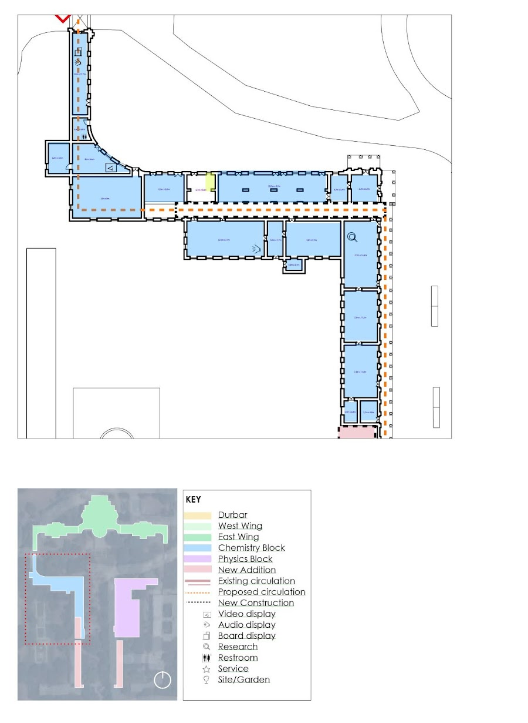
Hyderabad Exhibition Space of Nizam-British Museum and Cultural Centre (by Author)

The new addition to the south of the complex acknowledged the original structure, and extended corridors that terminated at the empress gate.

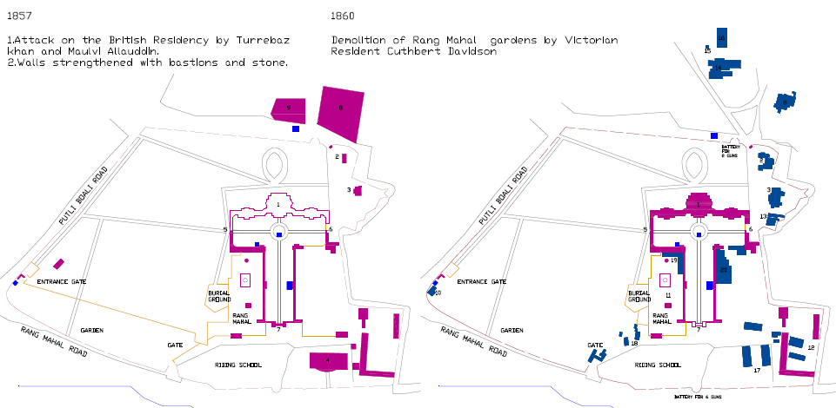
Image showing original pre-1857 plan of Residency building and development over time (source, Ar. Bindu Chandana)

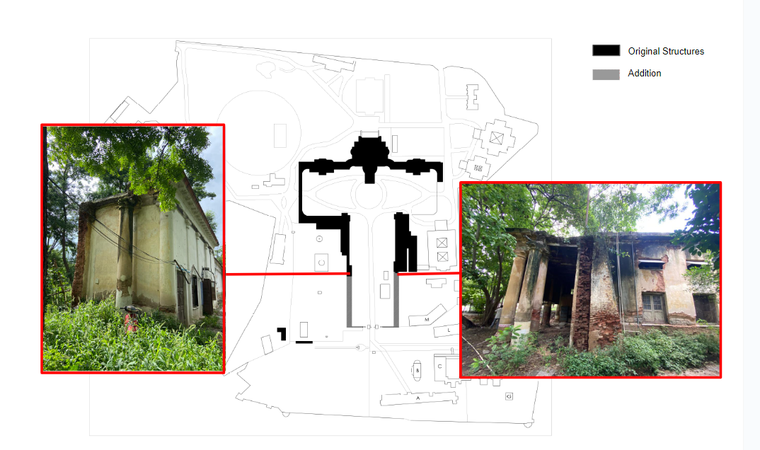
Diagram of British Residency showcasing addition and destruction of existing building (diagram and images by author)
The existence of such structures are confirmed through the 1813 painting of the British Residency complex from the southern, Musi River perspective, as well as visible destruction of the southern portion of the building. This destruction is believed to have occurred in 1908 during the great Musi River Flood.

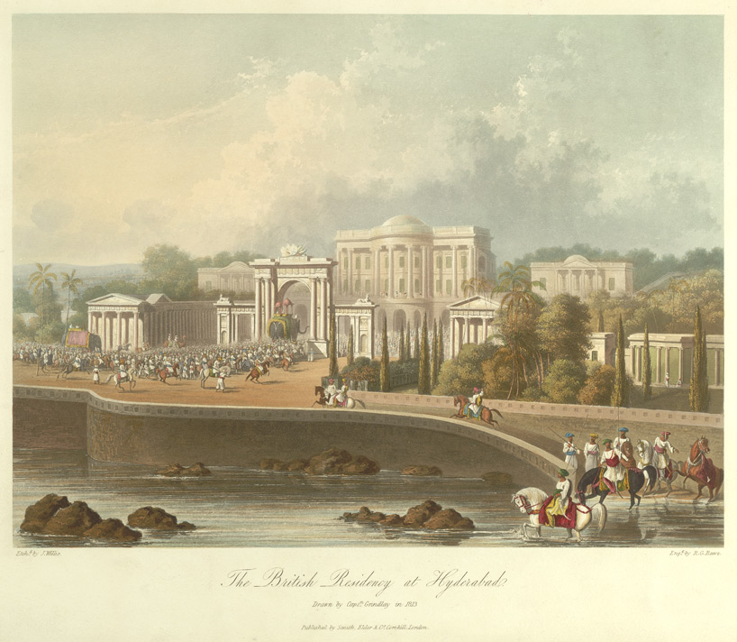
1813 painting of the British Residency

The design proposal seeks to showcase the exposed destruction of these sections as an opportunity to discuss the dichotomy between restored and not restored, past construction techniques and innovative preservation methods. Thus, the new addition is offset. This physical disconnect is highlighted through garden paths which lead to the cafe and exterior exhibits on the west, and a quiet meditative garden on the east portion of the site.

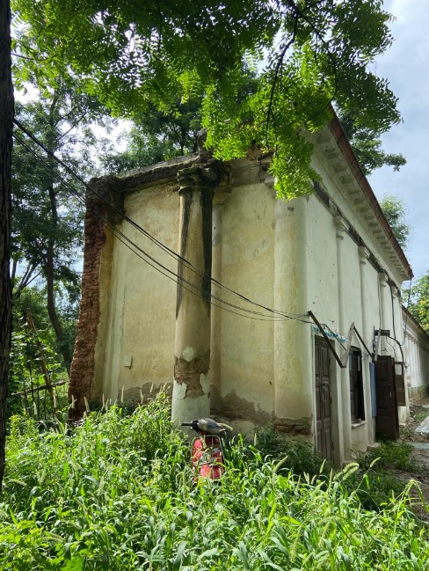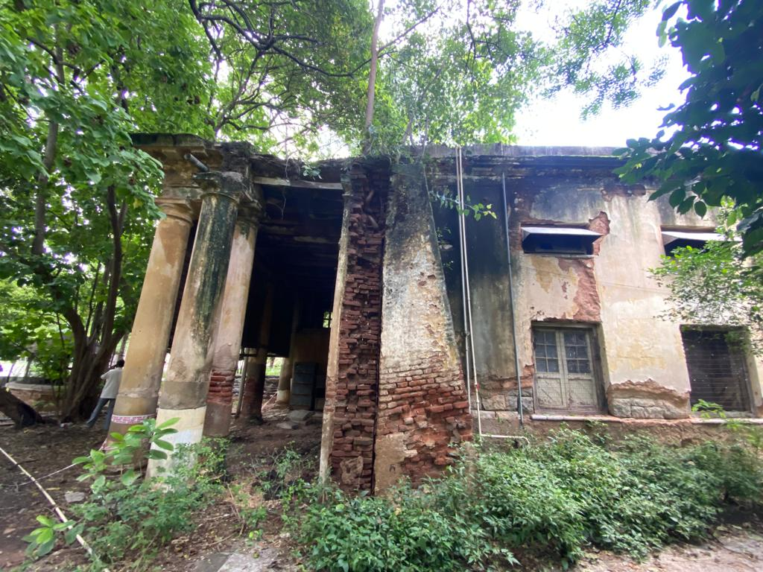
Southwest and southeast destruction of British Residency building (Images by Author, 2023)
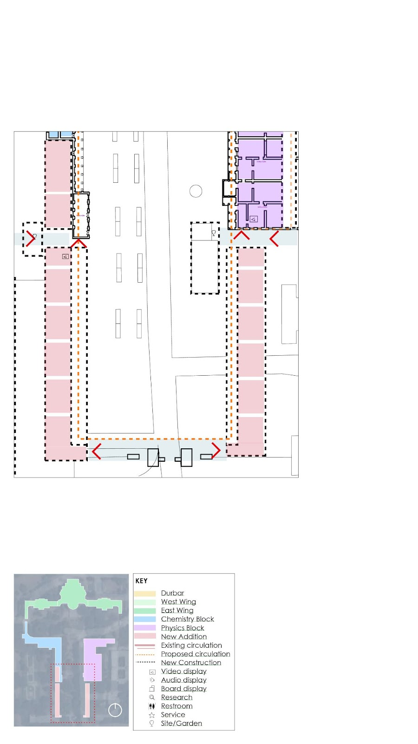
Plan of Southern Addition (Image by author)

Visitor experience is the primary focus of the Nizam-British Museum and Cultural Centre. Modes of display throughout the museum incorporate technology via interactive displays and screens. An app will guide visitors through the various exhibits and campus amenities which support both the exhibition and educational spaces. A unique aspect of this adaptive reuse proposal is the fact that the building is as much on display as the exhibits within it. The visitor’s ability to experience the volume of the original British Residency is seen through the experience of the landscape. Again, highlighting the southern entrance and view from the Empress gate, as well as the courtyard which showcases the grandeur of the southern entrance. The exterior gardens to the west of the building also support engaging views which currently draw visitors and student to the Residency building for pictures.

3. DISCUSSION

3.1 Author’s Reflections

Overarching matters of authenticity, wholeness, and narrative initiated the conception of this report. Such matters, along with the challenges of adaptive reuse for Heritage structures is discussed here in light of my own academic and personal perspective while designing this proposal for the Nizam-British Museum and Cultural Center.
My perception of the project in March, when I first learned of my assignment to Hyderabad through World Heritage USA, has completely shifted as I recognize the complexities of the highlighting of an authentic local narrative, amidst what some may term as a conflicting national sentiment. The fact that the Nizam-British relations of the colonial era featured relatively friendly and beneficial economic, social, and political outcomes for the state of Hyderabad– even to the extent of a relatively mild revolt during the 1857 Mutiny–amidst the rightly celebrated Independence from such foreign powers has allowed me to reflect on a distinct, yet akin situation in my own home country.
The United States Black Lives Matter not only highlighted the atrocity of inequity and discrimination, but it brought an important question to the table for all conservationists and champions of heritage preservation–What should be done about built symbols of challenging pasts?” The BLM Movement ignited campaigns to remove Confederate statues in light of their direct honouring of Confederate wartime leaders and the homage of disunion they seemingly perpetuated. Amidst the rallies and a number of forceful takedowns by activists, was a smaller voice calling for holistic reconstruction rather than outright demolition of such structures. These small, but thought-provoking, voices showcase the importance of physically representing more than a single story. Within the darkness of irrevocable oppression, there are stories of growth, progress, and success that are certainly worthy of recognition and even celebration.
Through this lens, I experienced the British Residency of Hyderabad. Not simply a structure, but a monument of grand scale which is may tempt viewers to see it solely as a sterile representation of the foreign rule that resided within its walls. The ruling that ensured a State protected monument came from the Andhra Pradesh High Court, despite the disapproval of the Archaeological Survey of India, which distinguished the Residency’s parallel in Lucknow, Uttar Pradesh. The British Residency Building in Lucknow was also the headquarters of colonial rule in the state, yet many also distinguish it as the site of the First War of Independence during the 1857 mutiny. This debatability of the British Residency in Hyderabad’s monumental status is simply the surface layer of the complex relationships between the British, indigenous residents, and local rulers in each district of India during their respective colonial histories. The social, political, and economic aspects of such rule are important to understand the current political, social, and economic challenges to preserving colonial structures in India. Yet, expressing a holistic narrative, just as with Confederate statements in the US, recognizes the residency as a point in history that contributed to the contemporary age. Utilizing the existing structure reveals the challenge of the apparent misalignment of local narratives with national narratives–an important aspect of discussion

3.2 Spaces for Further Discourse

Throughout the short design process, two additional issues were raised; the problem with the museum not being linked to the social contemporary (1) and the need to build new connections that do not damage the architectural, visual ambiance, and (2) authenticity of the historic structure. Such issues cannot be “solved” in a 2.5-month internship experience, yet inspire necessary discussion and collaboration among professionals in architecture and design as well as heritage and preservation. Through Vasaamaha and my personal social media channels, space for such discourse is being created digitally. Such platforms, encourage debate, inquiries, and further discussion which proliferate the life of the research above and welcome additional voices.
In all, the ability to work on such an immense project has been one of deep academic rigor and professional reflection.

4. ENDNOTES

1. Bakshi, Ashwani Kumar. 1991. Residency of Hyderabad (1779-1857). Department of History Osmania University
2. A Collection of Treaties, Engagements, and Sanads Relating to India and Neighbouring Countries. Compiled by C. U. Aitchison. 1909. Vol. 1. India: Office of the Superintendent of Government Printing, India, 1909.
3. “Colonial” is defined here as the influence of the French and British in the Deccan region, in addition to their colonial power or rule in the region.
4. Bakshi, Ashwani Kumar. 1991. Residency of Hyderabad (1779-1857). Department of History Osmania University
5. Splendors of the Raj: British architecture in Indus 1660-1947 , Davies Philip.94
6. Ibid.95
7. Turaga, Vasanta Sobha, M. Arch Research Paper “European Elements” 1997, SPA Delhi. “Today, Jan 3, 215 Yrs. Ago, Capt... - Vasaamaha Architects.” Facebook. Accessed September 6, 2023.
8. Splendors of the Raj: British architecture in Indus 1660-1947 , Davies Philip.77
9. Ibid.
10. Bakshi, Ashwani Kumar. 1991. Residency of Hyderabad (1779-1857). Department of History Osmania University
11. Bellet, Bertrand. “Glossary.” Glossary - International Council on Monuments and Sites. Accessed September 6, 2023. https://www.icomos.org/en/2016-11-10-13-53-13/icomos-and-the-world-heritage-convention-4#authenticity.
12. “Museum Definition.” International Council of Museums, June 5, 2023. https://icom.museum/en/resources/standards-guidelines/museum-definition/.
13. Hyderabad (Deccan): Chandrakunth Press, 1929. Journal of the Royal Asiatic Society, 67(1), 169-170. doi:10.1017/S0035869X00083465
14. Circar, or English spelling of sarkar, is a Mughal term for district
15. Farooqui, Salma Ahmed. “Masulipatnam--a Forgotten Hook in Shaping Hyderabad’s Destiny.” The Siasat Daily, October 6, 2022. https://www.siasat.com/masulipatnam-a-forgotten-hook-in-shaping-hyderabads-destiny-2428927/.
16. DATLA, KAVITA SARASWATHI. “The Origins of Indirect Rule in India: Hyderabad and the British Imperial Order.” Law and History Review 33, no. 2 (2015): 321–50. http://www.jstor.org/stable/43670778.
17. DATLA, KAVITA SARASWATHI. “The Origins of Indirect Rule in India: Hyderabad and the British Imperial Order.” Law and History Review 33, no. 2 (2015): 321–50. http://www.jstor.org/stable/43670778.
18. “Gunfoundry.” Department of Heritage Telangana. Accessed September 6, 2023. https://heritage.telangana.gov.in/monuments/gunfoundry/.
19. Splendors of the Raj: British architecture in Indus 1660-1947 , Davies Philip.94
20. Ibid.95
21. Define for clarity…
22. Shailender, Arya. “Secunderabad: Origins, Tales & Army Connection.” Salute, January 23, 2018. https://salute.co.in/secunderabad-origins-tales-army-connection/
23. Thesis, Osman Khan… 38.
24. Bawa, Vasant K. 1986. The Nizam Between Mughals and British : Hyderabad Under Salar Jung I. New Delhi: S. Chand.
25. Ali, Moulvie Syed Mahdi. “Hyderabad Affairs Vol.1 : Ali, Moulvie Syed Mahdi.” Internet Archive, January 1, 1883. https://archive.org/details/in.ernet.dli.2015.32068/page/n217/mode/2up. 854.
26. Shailender, Arya. “Secunderabad: Origins, Tales & Army Connection.” Salute, January 23, 2018. https://salute.co.in/secunderabad-origins-tales-army-connection/.
27. Ibid.
28. Ibid.
29. The Times of India (Bombay, India). 2017. “Visvesvaraya's Action-Plan May Have Answers to Waterlogging”, 2017.
30. Report on the Progress of The Hyderabad City improvement Board (for the Year 1349 Kasli (1939 to 1940 AD).

5. REFERENCES

Ali, Moulvie Syed Mahdi. “Hyderabad Affairs Vol.1: Ali, Moulvie Syed Mahdi.” Internet Archive, January 1, 1883. https://archive.org/details/in.ernet.dli.2015.32068/page/n217/mode/2up.
Alladin, Bilkiz. 1989. For the Love of a Begum. Hyderabad, India: Hydeca.
Bakshi, Ashwani Kumar. 1991. Residency of Hyderabad (1779-1857). Department of History Osmania University
Bawa, Vasant K. 2010. The Last Nizam: The Life and Times of Mir Osman Ali Khan. Hyderabad: Centre for Deccan Studies.
Bawa, Vasant K. 1986. The Nizam Between Mughals and British: Hyderabad Under Salar Jung I. New Delhi: S. Chand.
Bellet, Bertrand. “Glossary.” Glossary - International Council on Monuments and Sites. Accessed September 6, 2023. https://www.icomos.org/en/2016-11-10-13-53-13/icomos-and-the-world-heritage-convention-4#authenticity.
Briggs, Henry George. 1985. The Nizam, His History and Relations with the British Government. Delhi: Manas Publications.
Chandana, Bindu Bhargavi. Thesis on “Conservation Plan for the Historic Area of Residency, Hyderabad.” 2021.
Collection of Treaties, Engagements, and Sanad’s Relating to India and Neighbouring Countries. Compiled by C. U. Aitchison. 1909. Vol. 1. India: Office of the Superintendent of Government Printing, India, 1909.
Davies, Philip. Splendours of the Raj: British architecture in India, 1660-1947. London: J. Murray, 1985.
Dalrymple, William. White Mughals: Love and Betrayal in Eighteenth-Century India. New York: Viking, 2003.
Dalta, Kavita Saraswathi. “The Origins of Indirect Rule in India: Hyderabad and the British Imperial Order.” Law and History Review 33, no. 2 (2015): 321–50. http://www.jstor.org/stable/43670778.
Deccan. (2023, June 24). In Wikipedia. https://en.wikipedia.org/wiki/Deccan
Deen Dayal, Deen Dayal, and Kaple Kaple. 1885. James Bazar with Clock Tower, Secunderabad.
Farooqui, Salma Ahmed. “Masulipatnam--a Forgotten Hook in Shaping Hyderabad’s Destiny.” The Siasat Daily, October 6, 2022. https://www.siasat.com/masulipatnam-a-forgotten-hook-in-shaping-hyderabads-destiny-2428927/.
“Gunfoundry.” Department of Heritage Telangana. Accessed September 6, 2023. https://heritage.telangana.gov.in/monuments/gunfoundry/.
The Times of India (Bombay, India). 2017. “Visvesvaraya's Action-Plan May Have Answers to Waterlogging”, 2017.
Hyderabad (Deccan): Chandrakunth Press, 1929. Journal of the Royal Asiatic Society, 67(1), 169-170. doi:10.1017/S0035869X00083465
Khalidi, Omar. 1981. The British Residents at the Court of the Nizams of Hyderabad. Wichita, Kan.: Hyderabad Historical Society.
“Museum Definition.” International Council of Museums, June 5, 2023. https://icom.museum/en/resources/standards-guidelines/museum-definition/.
“Osmania Women’s College.” World Monuments Fund. Accessed September 6, 2023. https://www.wmf.org/project/osmania-womens-college.
Regani, Sarojini. Nizam-British Relations 1724-1857. Concept Publishing Company, 1963.
Rathore, Abhinay. “Rajput Princely States.” Rajput Provinces of India. https://www.indianrajputs.com/princelystates.php.
Shailender, Arya. “Secunderabad: Origins, Tales & Army Connection.” Salute, January 23, 2018. https://salute.co.in/secunderabad-origins-tales-army-connection/.
Stapleton, H. (1935). Pictorial Hyderabad. By K. Krishnaswamy Mudiraj. Vol. I, 11½ × 9, pp. xii 348, ills. 306. A
Turaga, Vasanta Sobha, M. Arch Thesis on Strategies for Conservation of Colonial Heritage of Hyderabad, 1997, SPA Delhi
Turaga, Vasanta Sobha, M. Arch Research Paper “European Elements” 1997, SPA Delhi.
“Today, Jan 3, 215 Yrs. Ago, Capt... - Vasaamaha Architects.” Facebook. Accessed September 6, 2023. https://www.facebook.com/100045195261785/posts/pfbid032SweqktohdsCpu6ubuzCfpWFb2WwtfXU91Yz1URGdazWCTGd3QkK9yWDeZrh7V4Tl/?mibextid=cr9u03.
Vasaamaha, Turaga Foundation, INTACH, Centre for VENUS. “Retracing connections: British Residency Bazar & the Hashmat Gunj Gate” 2021.
V.K. Bawa, 'Salar Jung and the Nizam's State Railway, 1860-1883,' The Indian Economic and Social History Review, Vol. 2, No. 4, 1965.
6. APPENDIX I
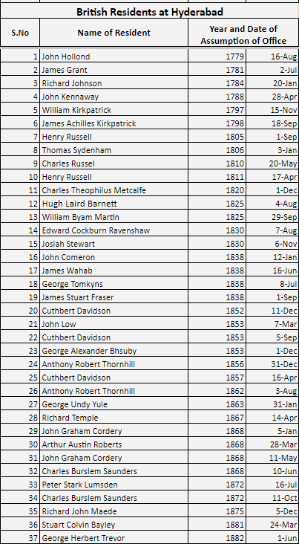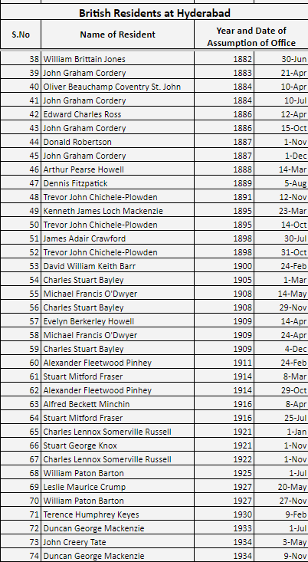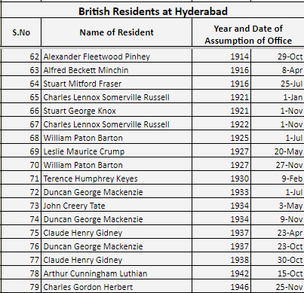

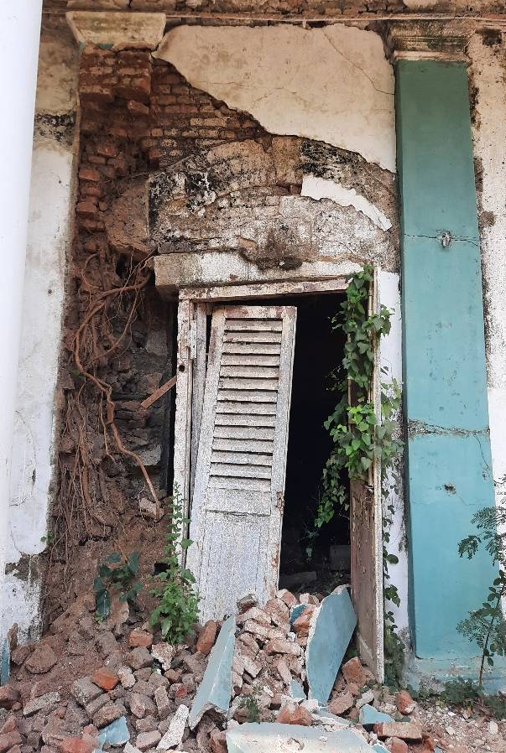

From British Residency to

Nizam-British Museum and Cultural Centre-

An Adaptive Reuse Design Project Report
Hyderabad, India

Schola Chioma Eburuoh

World Heritage USA IEP 2023 Intern

Vasaamaha Consultants, Hyderabad, Telangana, India

WH-USA International Exchange Program 2023
June - August 2023

